Caterpillar D25D Articulated Dump Truck
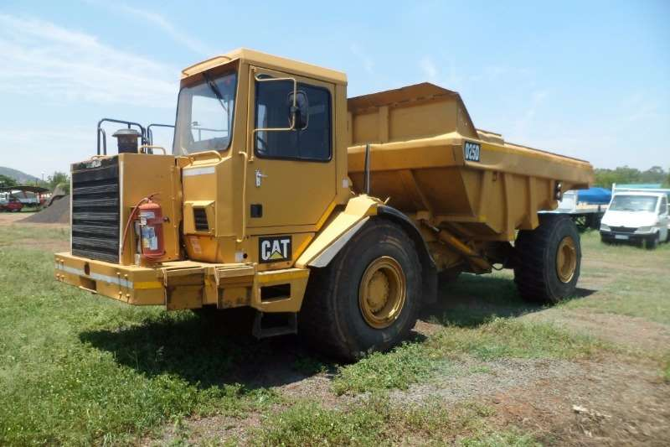

Dimensions
A Overall Length 8760 mm
B Overall Width 3000 mm
C Overall Height 3340 mm
D Wheelbase 4910 mm
F Dump Height 5340 mm

Specifications

Engine

Engine Make 2236

Engine Model 3306

Gross Power 193.9 kw

Operational

Fuel Capacity 450 L

Tire Size 26.5x25 Radials

Transmission

Number of Forward Gears 5

Max Speed 48 km/h

Weights

Front Axle – empty 13790 kg

Rear Axle – empty 5910 kg

Front Axle – loaded 20338 %

Rear Axle – loaded 22033 kg

Total Empty 19700 kg

Total Loaded 42371 kg

Dump Rated Payload 22671 kg

Capacity – Struck 10 m3

Capacity – Heaped 14 m3

Dimensions

Overall Length 8760 mm

Overall Width 3000 mm

Overall Height 3340 mm

Wheelbase 4910 mm

Dump Height 5340 mm

