CATERPILLAR 438c Loader Backhoe
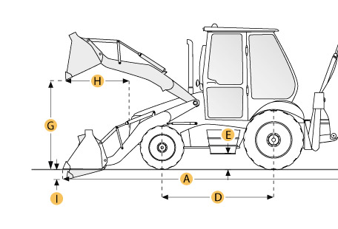

Selected Dimensions
Backhoe
J. Load Height - Std | 12.1 ft in | 3684 mm
K. Reach From Swivel - Std | 18.7 ft in | 5711 mm
L. Dig Depth - Std | 16 ft in | 4873 mm
M. Reach at Load Height - Std | 5.4 ft in | 1660 mm
Dimensions
A. Transport Length | 18.8 ft in | 5740 mm
B. Transport Width | 7.9 ft in | 2396 mm
C. Transport Height | 12.4 ft in | 3765 mm
D. Wheelbase | 6.9 ft in | 2100 mm
E. Ground Clearance | 1.1 ft in | 335 mm
F. Height to Top of Cab | 9.5 ft in | 2900 mm
Loader
G. Clearance at Max Dump Height | 8.7 ft in | 2655 mm
H. Reach at Max Dump Height | 2.6 ft in | 780 mm
I. Dig Depth | 1.6 in | 40 mm

Specification
Engine
Make | Caterpillar
Model | 3054
Net Power | 85 hp | 63.4 kw
Gross Power | 89 hp | 66.4 kw
Displacement | 244.1 cu in | 4 L
Power Measured @ | 2200 rpm
Number of Cylinders | 4
Net Torque Rise | 24.1 %
Aspiration | Turbocharged
Operational
Operating Weight 4wd | 16666.9 lb | 7560 kg
Fuel Capacity | 33.8 gal | 128 L
Hydraulic System Fluid Capacity | 20.9 gal | 79 L
Oil System Fluid Capacity | 1.9 gal | 7.3 L
Cooling System Fluid Capacity | 5.7 gal | 21.6 L
Transmission Fluid Capacity | 4.8 gal | 18 L
Front Axle Fluid Capacity | 2 gal | 7.5 L
Rear Axle Fluid Capacity | 6.3 gal | 24 L
Turning Radius | 26.5 ft in | 8090 mm
Tire Size Front - 2wd / 4wd | 335/80 x R18
Rear Tires Size 2wd/4wd | 16.9 x R28
Operating Voltage | 12 V
Alternator Supplied Amperage | 52 amps
Transmission
Type | Power Shuttle
Number of Forward Gears | 4
Number of Reverse Gears | 4
Max Speed - Forward | 19.6 mph | 31.5 km/h
Max Speed Reverse | 19.6 mph | 31.5 km/h
Backhoe
Dig Depth - Std | 16 ft in | 4873 mm
Dig Depth - Ext | 19.4 ft in | 5924 mm
Reach From Swivel - Std | 18.7 ft in | 5711 mm
Reach From Swivel - Ext | 22.2 ft in | 6756 mm
Load Height - Std | 12.1 ft in | 3684 mm
Load Height - Ext | 14.3 ft in | 4344 mm
Reach at Load Height - Std | 5.4 ft in | 1660 mm
Reach at Load Height - Ext | 8.5 ft in | 2596 mm
Loader
Bucket Capacity | 1.3 yd3 | 1 m3
Bucket Width | 94.3 in | 2396 mm
Bucket Breakout Force | 11330.4 lb | 50.4 kN
Clearance at Max Dump Height | 8.7 ft in | 2655 mm
Reach at Max Dump Height | 2.6 ft in | 780 mm
Dig Depth | 1.6 in | 40 mm
Hydraulic
Pump Type | Piston
Pump Flow Capacity | 42.8 gal/min | 162 L/min
Relief Valve Pressure | 3000 psi | 20684.3 kPa
Dimensions
Transport Length | 18.8 ft in | 5740 mm
Transport Width | 7.9 ft in | 2396 mm
Transport Height | 12.4 ft in | 3765 mm
Height to Top of Cab | 9.5 ft in | 2900 mm
Wheelbase | 6.9 ft in | 2100 mm
Ground Clearance | 1.1 ft in | 335 mm

