JCB 3c Loader Backhoe
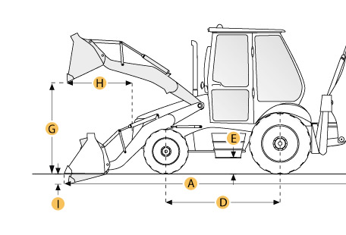

Selected Dimensions
Backhoe
J. Load Height - Std | 10.3 ft in | 3150 mm
K. Reach From Swivel - Std | 17.6 ft in | 5360 mm
L. Dig Depth - Std | 14.3 ft in | 4370 mm
M. Reach at Load Height - Std | 5.7 ft in | 1730 mm
Dimensions
A. Transport Length | 18.1 ft in | 5520 mm
B. Transport Width | 13.9 ft in | 4240 mm
C. Transport Height | 11.2 ft in | 3400 mm
D. Wheelbase | 6.9 ft in | 2110 mm
E. Ground Clearance | 1.1 ft in | 350 mm
F. Height to Top of Cab | 9.3 ft in | 2820 mm
Loader
G. Clearance at Max Dump Height | 8.8 ft in | 2690 mm
H. Reach at Max Dump Height | 2.7 ft in | 810 mm
I. Dig Depth | 5.1 in | 130 mm

Specification
Engine
Gross Power | 85 hp | 63.4 kw
Net Power | 82.6 hp | 61.6 kw
Displacement | 268.5 cu in | 4.4 L
Power Measured @ | 2200 rpm
Torque Measured @ | 1200 rpm
Number of Cylinders | 4
Net Max Torque | 315.6 lb ft | 427.9 Nm
Aspiration | Natural Aspirated
Operational
Operating Weight 2wd | 14278 lb | 6476.4 kg
Operating Weight 4wd | 14586 lb | 6616.1 kg
Max Weight | 16302 lb | 7394.5 kg
Fuel Capacity | 34.3 gal | 130 L
Hydraulic System Fluid Capacity | 30.4 gal | 115 L
Oil System Fluid Capacity | 4 gal | 15 L
Cooling System Fluid Capacity | 4.9 gal | 18.5 L
Transmission Fluid Capacity | 4.2 gal | 16 L
Rear Axle Fluid Capacity | 4.2 gal | 16 L
Turning Radius | 13.2 ft in | 4025 mm
Tire Size Front - 2wd / 4wd | 11L-16, 12 ply-front, 14-17.5, FWD, 10 ply-front
Rear Tires Size 2wd/4wd | 15.9-24, R4, 12 ply-rear
Operating Voltage | 12 V
Alternator Supplied Amperage | 95 amps
Transmission
Type | JCB synchroshuttle
Number of Forward Gears | 4
Number of Reverse Gears | 4
Max Speed - Forward | 20.6 mph | 33.2 km/h
Max Speed Reverse | 20.6 mph | 33.2 km/h
Backhoe
Dig Depth - Std | 14.3 ft in | 4370 mm
Dig Depth - Ext | 18 ft in | 5490 mm
Reach From Swivel - Std | 17.6 ft in | 5360 mm
Reach From Swivel - Ext | 21 ft in | 6400 mm
Load Height - Std | 10.3 ft in | 3150 mm
Load Height - Ext | 11.8 ft in | 3610 mm
Reach at Load Height - Std | 5.7 ft in | 1730 mm
Reach at Load Height - Ext | 9.1 ft in | 2770 mm
Loader
Bucket Capacity | 1.3 yd3 | 0.96 m3
Bucket Width | 88 in | 2235.2 mm
Bucket Breakout Force | 12127 lb | 53.9 kN
Lift Capacity at Full Height | 6211 lb | 2817.3 kg
Clearance at Max Dump Height | 8.8 ft in | 2690 mm
Reach at Max Dump Height | 2.7 ft in | 810 mm
Dig Depth | 5.1 in | 130 mm
Hydraulic
Pump Type | single gear pump
Pump Flow Capacity | 23.8 gal/min | 90 L/min
Relief Valve Pressure | 3300 psi | 22752.7 kPa
Dimensions
Transport Length | 18.1 ft in | 5520 mm
Transport Width | 13.9 ft in | 4240 mm
Transport Height | 11.2 ft in | 3400 mm
Height to Top of Cab | 9.3 ft in | 2820 mm
Wheelbase | 6.9 ft in | 2110 mm
Ground Clearance | 1.1 ft in | 350 mm

