Caterpillar 428 Series II Loader Backhoe
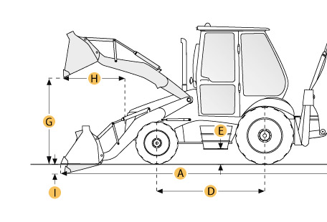

Selected Dimensions
Backhoe
J. Load Height - Std | 11.4 ft in | 3486 mm
K. Reach From Swivel - Std | 17.6 ft in | 5377 mm
L. Dig Depth - Std | 15.6 ft in | 4750 mm
Dimensions
A. Transport Length | 18.7 ft in | 5685 mm
B. Transport Width | 7.9 ft in | 2406 mm
C. Transport Height | 11.7 ft in | 3574 mm
D. Wheelbase | 6.9 ft in | 2100 mm
E. Ground Clearance | 1 ft in | 320 mm
F. Height to Top of Cab | 9.1 ft in | 2776 mm
Loader
G. Clearance at Max Dump Height | 8.7 ft in | 2643 mm
H. Reach at Max Dump Height | 2.8 ft in | 844 mm
I. Dig Depth | 3.9 in | 99 mm

Specification
Engine
Make | Perkins
Model | 4.2
Net Power | 69.7 hp | 52 kw
Gross Power | 75.1 hp | 56 kw
Displacement | 235.6 cu in | 3.9 L
Operational
Operating Weight 2wd | 15747.6 lb | 7143 kg
Turning Radius | 12.8 ft in | 3914 mm
Tire Size Front - 2wd / 4wd | 9-16 10PR / 10.5-20 10PR
Rear Tires Size 2wd/4wd | 16.9-28 10 PR
Transmission
Number of Forward Gears | 4
Number of Reverse Gears | 4
Max Speed - Forward | 18.3 mph | 29.4 km/h
Max Speed Reverse | 18.4 mph | 29.6 km/h
Backhoe
Dig Depth - Std | 15.6 ft in | 4750 mm
Dig Depth - Ext | 19.7 ft in | 5998 mm
Reach From Swivel - Std | 17.6 ft in | 5377 mm
Reach From Swivel - Ext | 21.7 ft in | 6629 mm
Bucket Dig Force - Std | 10438 lb | 4734.6 kg
Bucket Dig Force - Ext | 10258 lb | 4653 kg
Load at Max Lift - Std | 3836 lb | 1740 kg
Load at Max Lift - Ext | 2116.4 lb | 960 kg
Load Height - Std | 11.4 ft in | 3486 mm
Load Height - Ext | 13.8 ft in | 4192 mm
Loader
Bucket Capacity | 1.3 yd3 | 1 m3
Bucket Width | 94.3 in | 2396 mm
Bucket Breakout Force | 8048.2 lb | 35.8 kN
Lift Capacity at Full Height | 5249.2 lb | 2381 kg
Clearance at Max Dump Height | 8.7 ft in | 2643 mm
Reach at Max Dump Height | 2.8 ft in | 844 mm
Dig Depth | 3.9 in | 99 mm
Hydraulic
Pump Flow Capacity | 28.5 gal/min | 108 L/min
Relief Valve Pressure | 2700 psi | 18615.8 kPa
Dimensions
Transport Length | 18.7 ft in | 5685 mm
Transport Width | 7.9 ft in | 2406 mm
Transport Height | 11.7 ft in | 3574 mm
Height to Top of Cab | 9.1 ft in | 2776 mm
Wheelbase | 6.9 ft in | 2100 mm
Ground Clearance | 1 ft in | 320 mm

