CATERPILLAR 224 Mobile Excavator
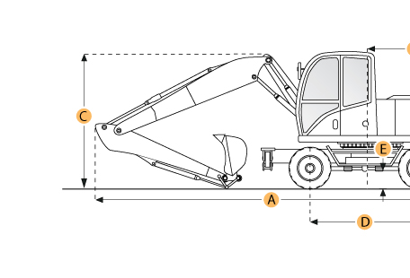

Selected Dimensions

Boom/Stick Option
I. Max Cutting Height | 25.6 ft in | 7800 mm
J. Max Loading Height | 18 ft in | 5500 mm
K. Max Reach Along Ground | 28.2 ft in | 8610 mm
M. Max Digging Depth | 18 ft in | 5490 mm
Dimensions
B. Overall Width | 8.2 ft in | 2490 mm
D. Wheelbase | 8.7 ft in | 2650 mm
E. Ground Clearance | 1.1 ft in | 350 mm
F. Overall Width - Outriggers Down | 12 ft in | 3650 mm
G. Height to Top of Cab | 10.5 ft in | 3213 mm
N. Upper Structure Clearance | 4.2 ft in | 1275 mm

Specification
Engine
Make | Deutz
Model | BF6L 913
Gross Power | 143.5 hp | 107 kw
Displacement | 374.1 cu in | 6.1 L
Operational
Fuel Capacity | 60.8 gal | 230 L
Hydraulic System Fluid Capacity | 92.5 gal | 350 L
Hydraulic System Relief Valve Pressure | 4351.1 psi | 30000 kPa
Hydraulic Pump Flow Capacity | 85.6 gal/min | 324 L/min
Tire Size | dual 10.00-20
Boom/Stick Option (MEX) 1
Boom/Stick Option (MEX) 1 | One-Piece Boom/Stick 5'11" (1800mm)
Max Digging Depth | 18 ft in | 5490 mm
Max Reach Along Ground | 28.2 ft in | 8610 mm
Max Cutting Height | 25.6 ft in | 7800 mm
Max Loading Height | 18 ft in | 5500 mm
Boom/Stick Option (MEX) 2
Boom/Stick Option (MEX) 2 | One-Piece Boom/Stick 7'6.5" (2300mm)
Max Digging Depth | 19.5 ft in | 5950 mm
Max Reach Along Ground | 30.2 ft in | 9200 mm
Max Cutting Height | 26.1 ft in | 7950 mm
Boom/Stick Option (MEX) 3
Boom/Stick Option (MEX) 3 | One-Piece Boom/Stick 9'2" (2800mm)
Max Digging Depth | 21.3 ft in | 6500 mm
Max Reach Along Ground | 31.8 ft in | 9680 mm
Max Cutting Height | 25.3 ft in | 7700 mm
Boom/Stick Option (MEX) 4
Boom/Stick Option (MEX) 4 | Two-Piece Boom/Stick 5'11" (1800mm)
Max Digging Depth | 16.4 ft in | 5000 mm
Max Reach Along Ground | 29.7 ft in | 9050 mm
Max Cutting Height | 30.2 ft in | 9200 mm
Max Loading Height | 22.1 ft in | 6750 mm
Dimensions
Overall Width | 8.2 ft in | 2490 mm
Overall Width - Outriggers Down | 12 ft in | 3650 mm
Height to Top of Cab | 10.5 ft in | 3213 mm
Wheelbase | 8.7 ft in | 2650 mm
Ground Clearance | 1.1 ft in | 350 mm
Upper Structure Clearance | 4.2 ft in | 1275 mm

