Caterpillar 773 Rock Truck
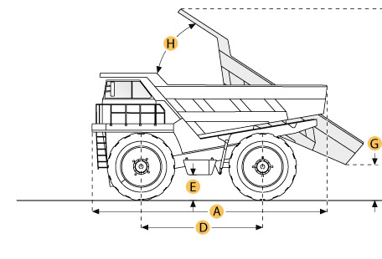

Selected Dimensions
Dimensions
A. Overall Length | 28.6 ft in | 8712 mm
B. Overall Width | 12.5 ft in | 3800 mm
C. Overall Height | 13.8 ft in | 4200 mm
D. Wheelbase | 13 ft in | 3962 mm
F. Dump Height | 27.2 ft in | 8300 mm
G. Dump Ground Clearance | 11.3 ft in | 3450 mm

Specification
Engine
Make | Caterpillar
Model | D346
Gross Power | 600 hp | 447.4 kw
Displacement | 1190 cu in | 19.5 L
Operational
Fuel Capacity | 179.6 gal | 680 L
Tire Size | 21-35 32PR
Transmission
Max Speed | 42 mph | 67.6 km/h
Weights
Empty Weight | 83334.7 lb | 37800 kg
Loaded Weight | 183358.5 lb | 83170 kg
Dump
Rated Payload | 100000 lb | 45359.2 kg
Load Capacity - Struck | 30.6 yd3 | 23.4 m3
Load Capacity - heaped | 40.9 yd3 | 31.3 m3
Dimensions
Overall Length | 28.6 ft in | 8712 mm
Overall Width | 12.5 ft in | 3800 mm
Overall Height | 13.8 ft in | 4200 mm
Wheelbase | 13 ft in | 3962 mm
Dump Height | 27.2 ft in | 8300 mm
Dump Ground Clearance | 11.3 ft in | 3450 mm

