Caterpillar 789 Rock Truck
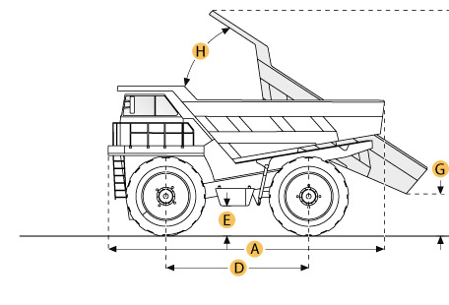

Selected Dimensions
Dimensions
A. Overall Length | 40 ft in | 12180 mm
B. Overall Width | 24.1 ft in | 7340 mm
C. Overall Height | 20.2 ft in | 6150 mm
D. Wheelbase | 18.7 ft in | 5700 mm
F. Dump Height | 39.1 ft in | 11910 mm

Specification
Engine
Make | Caterpillar
Model | 3516
Gross Power | 1800 hp | 1342.3 kw
Net Power | 1705 hp | 1271.4 kw
Displacement | 4216.7 cu in | 69.1 L
Operational
Fuel Capacity | 851.2 gal | 3222 L
Tire Size | 37.00R57 (E-4)
Transmission
Number of Gears - Forward | 6
Max Speed | 33.6 mph | 54 km/h
Weights
Empty Weight | 268792 lb | 121922 kg
Loaded Weight | 699879.5 lb | 317460 kg
Weight Distribution Front - empty | 47 %
Weight Distribution Rear - empty | 53 %
Weight Distribution Front - loaded | 33 %
Weight Distribution Rear - loaded | 67 %
Dump
Rated Payload | 390000 lb | 176901 kg
Load Capacity - Struck | 95.5 yd3 | 73 m3
Load Capacity - heaped | 137.3 yd3 | 105 m3
Dimensions
Overall Length | 40 ft in | 12180 mm
Overall Width | 24.1 ft in | 7340 mm
Overall Height | 20.2 ft in | 6150 mm
Wheelbase | 18.7 ft in | 5700 mm
Dump Height | 39.1 ft in | 11910 mm

