Caterpillar 224B Mobile Excavator
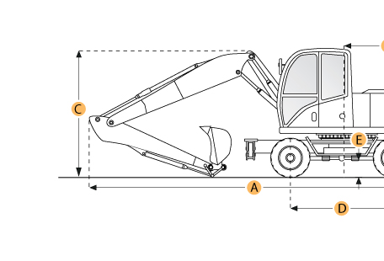

Selected Dimensions

Boom/Stick Option
I. Max Cutting Height | 26.5 ft in | 8070 mm
J. Max Loading Height | 18.1 ft in | 5523 mm
K. Max Reach Along Ground | 28.8 ft in | 8763 mm
L. Max Vertical Wall Dig Depth | 9.6 ft in | 2940 mm
M. Max Digging Depth | 18.1 ft in | 5523 mm
Dimensions
B. Overall Width | 8.7 ft in | 2660 mm
D. Wheelbase | 9 ft in | 2750 mm
E. Ground Clearance | 1.1 ft in | 340 mm
F. Overall Width - Outriggers Down | 12.7 ft in | 3870 mm
G. Height to Top of Cab | 10.5 ft in | 3190 mm
N. Upper Structure Clearance | 4.2 ft in | 1290 mm

Specification

Engine
Make | Caterpillar
Model | 3116
Gross Power | 135 hp | 100.7 kw
Displacement | 402.8 cu in | 6.6 L
Operational
Fuel Capacity | 87.2 gal | 330 L
Hydraulic System Fluid Capacity | 103 gal | 390 L
Hydraulic System Relief Valve Pressure | 4641.2 psi | 32000 kPa
Hydraulic Pump Flow Capacity | 87.2 gal/min | 330 L/min
Tire Size | dual 10.00-20 12PR
Boom/Stick Option (MEX) 1
Boom/Stick Option (MEX) 1 | Stick 5'11" (1800mm)
Max Digging Depth | 18.1 ft in | 5523 mm
Max Reach Along Ground | 28.8 ft in | 8763 mm
Max Cutting Height | 26.5 ft in | 8070 mm
Max Loading Height | 18.1 ft in | 5523 mm
Max Vertical Wall Dig Depth | 9.6 ft in | 2940 mm
Boom/Stick Option (MEX) 2
Boom/Stick Option (MEX) 2 | Stick 7'7" (2300mm)
Max Digging Depth | 19.8 ft in | 6025 mm
Max Reach Along Ground | 30.3 ft in | 9237 mm
Max Cutting Height | 27.2 ft in | 8297 mm
Max Loading Height | 18.8 ft in | 5728 mm
Max Vertical Wall Dig Depth | 11.5 ft in | 3513 mm
Boom/Stick Option (MEX) 3
Boom/Stick Option (MEX) 3 | Stick 9'2" (2800mm)
Max Digging Depth | 21.4 ft in | 6510 mm
Max Reach Along Ground | 31.5 ft in | 9610 mm
Max Cutting Height | 26.5 ft in | 8092 mm
Max Loading Height | 18.6 ft in | 5679 mm
Max Vertical Wall Dig Depth | 9.8 ft in | 2980 mm
Boom/Stick Option (MEX) 4
Boom/Stick Option (MEX) 4 | Stick 13'2" (4000mm)
Max Digging Depth | 25.3 ft in | 7710 mm
Max Reach Along Ground | 35.3 ft in | 10750 mm
Max Cutting Height | 27.9 ft in | 8490 mm
Max Loading Height | 19.9 ft in | 6070 mm
Max Vertical Wall Dig Depth | 13.1 ft in | 4000 mm
Dimensions
Overall Width | 8.7 ft in | 2660 mm
Overall Width - Outriggers Down | 12.7 ft in | 3870 mm
Height to Top of Cab | 10.5 ft in | 3190 mm
Wheelbase | 9 ft in | 2750 mm
Ground Clearance | 1.1 ft in | 340 mm
Upper Structure Clearance | 4.2 ft in | 1290 mm

