Caterpillar 777 Rock Truck
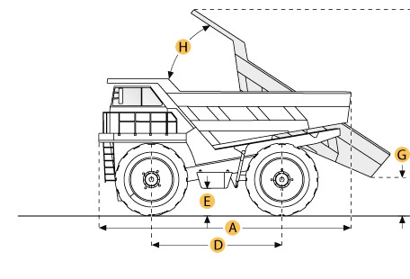

Selected Dimensions
Dimensions
A. Overall Length | 32.2 ft in | 9800 mm
B. Overall Width | 11.5 ft in | 3506 mm
C. Overall Height | 16.1 ft in | 4903 mm
D. Wheelbase | 15 ft in | 4572 mm
F. Dump Height | 30.5 ft in | 9300 mm
G. Dump Ground Clearance | 13.6 ft in | 4140 mm

Specification
Engine
Make | Caterpillar
Model | D348
Gross Power | 870 hp | 648.8 kw
Displacement | 1788 cu in | 29.3 L
Operational
Fuel Capacity | 250.2 gal | 947 L
Tire Size | 24x49 42 PR
Transmission
Max Speed | 36.2 mph | 58.3 km/h
Weights
Empty Weight | 124402.5 lb | 56428 kg
Loaded Weight | 294405.3 lb | 133540 kg
Dump
Rated Payload | 170000 lb | 77110.7 kg
Load Capacity - Struck | 47.5 yd3 | 36.3 m3
Load Capacity - heaped | 67.1 yd3 | 51.3 m3
Dimensions
Overall Length | 32.2 ft in | 9800 mm
Overall Width | 11.5 ft in | 3506 mm
Overall Height | 16.1 ft in | 4903 mm
Wheelbase | 15 ft in | 4572 mm
Dump Height | 30.5 ft in | 9300 mm
Dump Ground Clearance | 13.6 ft in | 4140 mm

