CATERPILLAR 416c Loader Backhoe
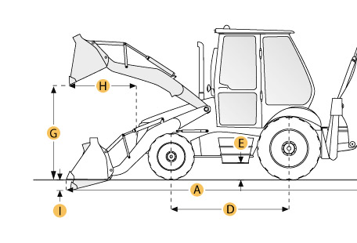

Selected Dimensions
Backhoe
J. Load Height - Std | 11.4 ft in | 3483 mm
L. Dig Depth - Std | 14.5 ft in | 4420 mm
M. Reach at Load Height - Std | 5.8 ft in | 1764 mm
Dimensions
A. Transport Length | 22.9 ft in | 6980 mm
B. Transport Width | 7.7 ft in | 2352 mm
C. Transport Height | 11.8 ft in | 3585 mm
D. Wheelbase | 6.9 ft in | 2100 mm
E. Ground Clearance | 0.97 ft in | 297 mm
F. Height to Top of Cab | 9.1 ft in | 2770 mm
Loader
H. Reach at Max Dump Height | 2.4 ft in | 730 mm
I. Dig Depth | 4.1 in | 105 mm

Specification
Engine
Make | Caterpillar
Model | 3054 DIT
Gross Power | 78 hp | 58.2 kw
Net Power | 75 hp | 55.9 kw
Displacement | 243 cu in | 4 L
Power Measured @ | 2200 rpm
Number of Cylinders | 4
Operational
Operating Weight 2wd | 13960 lb | 6332.1 kg
Fuel Capacity | 33.8 gal | 128 L
Tire Size Front - 2wd / 4wd | 11L-16, 12PR, F3
Rear Tires Size 2wd/4wd | 16.9-24, 10 PR, R4
Transmission
Number of Forward Gears | 4
Number of Reverse Gears | 4
Max Speed - Forward | 20.4 mph | 32.8 km/h
Max Speed Reverse | 20.4 mph | 32.8 km/h
Backhoe
Dig Depth - Std | 14.5 ft in | 4420 mm
Dig Depth - Ext | 18.2 ft in | 5545 mm
Bucket Dig Force - Std | 11700 lb | 5307 kg
Bucket Dig Force - Ext | 12065 lb | 5472.6 kg
Load Height - Std | 11.4 ft in | 3483 mm
Load Height - Ext | 13.9 ft in | 4223 mm
Reach at Load Height - Std | 5.8 ft in | 1764 mm
Reach at Load Height - Ext | 8.9 ft in | 2706 mm
Loader
Bucket Capacity | 0.99 yd3 | 0.76 m3
Bucket Width | 89.1 in | 2262 mm
Bucket Breakout Force | 9030 lb | 40.2 kN
Lift Capacity at Full Height | 5780 lb | 2621.8 kg
Reach at Max Dump Height | 2.4 ft in | 730 mm
Dig Depth | 4.1 in | 105 mm
Hydraulic
Pump Flow Capacity | 43.1 gal/min | 163 L/min
Dimensions
Transport Length | 22.9 ft in | 6980 mm
Transport Width | 7.7 ft in | 2352 mm
Transport Height | 11.8 ft in | 3585 mm
Height to Top of Cab | 9.1 ft in | 2770 mm
Wheelbase | 6.9 ft in | 2100 mm
Ground Clearance | 0.97 ft in | 297 mm

