CATERPILLAR 432d Loader Backhoe

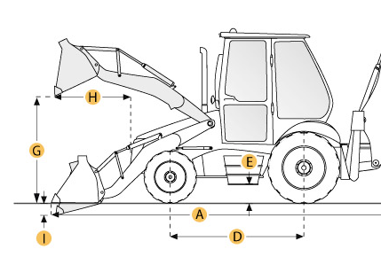

Selected Dimensions
Backhoe
J. Load Height - Std | 12.2 ft in | 3712 mm
K. Reach From Swivel - Std | 18.5 ft in | 5637 mm
L. Dig Depth - Std | 15.9 ft in | 4854 mm
M. Reach at Load Height - Std | 5.7 ft in | 1742 mm
Dimensions
A. Transport Length | 18.9 ft in | 5760 mm
B. Transport Width | 7.9 ft in | 2396 mm
C. Transport Height | 12.3 ft in | 3740 mm
D. Wheelbase | 6.9 ft in | 2100 mm
E. Ground Clearance | 1 ft in | 320 mm
F. Height to Top of Cab | 9.5 ft in | 2900 mm
Loader
G. Clearance at Max Dump Height | 8.6 ft in | 2613 mm
H. Reach at Max Dump Height | 2.5 ft in | 764 mm
I. Dig Depth | 3 in | 77 mm

Specification
Engine
Make | Caterpillar
Model | 3054T
Gross Power | 88 hp | 65.6 kw
Net Power | 85 hp | 63.4 kw
Displacement | 244.1 cu in | 4 L
Power Measured @ | 2200 rpm
Number of Cylinders | 4
Operational
Operating Weight 4wd | 17215.9 lb | 7809 kg
Fuel Capacity | 33.8 gal | 128 L
Turning Radius | 17.6 ft in | 5350 mm
Tire Size Front - 2wd / 4wd | 12.5/80x18,10PR
Rear Tires Size 2wd/4wd | 16.9x28,10PR
Transmission
Type | power shuttle
Number of Forward Gears | 4
Number of Reverse Gears | 4
Max Speed - Forward | 19.8 mph | 31.8 km/h
Max Speed Reverse | 19.8 mph | 31.8 km/h
Backhoe
Dig Depth - Std | 15.9 ft in | 4854 mm
Dig Depth - Ext | 19.3 ft in | 5894 mm
Reach From Swivel - Std | 18.5 ft in | 5637 mm
Reach From Swivel - Ext | 21.9 ft in | 6664 mm
Bucket Dig Force - Std | 14710 lb | 6672.3 kg
Bucket Dig Force - Ext | 14580 lb | 6613.4 kg
Load Height - Std | 12.2 ft in | 3712 mm
Load Height - Ext | 14 ft in | 4274 mm
Reach at Load Height - Std | 5.7 ft in | 1742 mm
Reach at Load Height - Ext | 9 ft in | 2747 mm
Loader
Bucket Capacity | 1.3 yd3 | 1 m3
Bucket Width | 94.3 in | 2396 mm
Bucket Breakout Force | 11285.4 lb | 50.2 kN
Lift Capacity at Full Height | 7645.6 lb | 3468 kg
Clearance at Max Dump Height | 8.6 ft in | 2613 mm
Reach at Max Dump Height | 2.5 ft in | 764 mm
Dig Depth | 3 in | 77 mm
Hydraulic
Pump Type | LSPC, closed center
Pump Flow Capacity | 43.1 gal/min | 163 L/min
Relief Valve Pressure | 3306.9 psi | 22800 kPa
Dimensions
Transport Length | 18.9 ft in | 5760 mm
Transport Width | 7.9 ft in | 2396 mm
Transport Height | 12.3 ft in | 3740 mm
Height to Top of Cab | 9.5 ft in | 2900 mm
Wheelbase | 6.9 ft in | 2100 mm
Ground Clearance | 1 ft in | 320 mm

