KOMATSU PC100L-6E
Серия avance Выпуск 97-
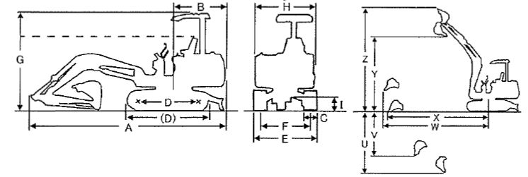
ОСНОВНЫЕ ХАРАКТЕРИСТИКИ  Рабочий вес, кг: 13800  Объем стандартного ковша, m3 /0.45  Ширина стандартного ковша, mm  РАЗМЕРЫ  Длина общая, mm (A): 7170  Радиус задней части, mm (B): 2130  Ширина траков, mm (C): 800  Длина трака, mm (D): 2910  Длина гусеницы, mm ((D)): 3820  Ширина ходовой части, mm (E): 2770  Ширина колеи, mm (F): 1970  Общая высота, mm (G): 2980  Общая ширина, mm (H): 2770  Дорожный просвет (клиренс), mm(I)  Длина стрелы (высота), mm: 2360  ДВИГАТЕЛЬ  Марка двигателя: KOM  Модель двигателя: S4D102E  Мощность (KW(PS)/rpm): 60.3(82)/2100  Макс. вращение (N-m(min-1): N/A  Количество цилиндров: 4  Размер поршня: N/A  Рабочий объем двигателя, л: 3.9 |  | ГИДРАВЛИЧЕСКАЯ УСТАНОВКА  Установка предохранительных клапанов (MPA): 34.8  Тип гидравлического насоса: PPP  ПРОИЗВОДИТЕЛЬНОСТЬ  Преодолеваемый подъем (deg): 35  Усилие на стреле (kn): /54.9,59.8(HPM)  Усилие на ковше (kn): /84.0,91.7(HPM)  Макс. глубина копания, mm (U): 4820  Макс. глубина копания, mm (V): 4820  Макс. радиус копания, mm (W): 7530  Макс. радиус копания на глубине, mm (X): 7720  Макс. высота разгрузки, mm (Y): 5970  Макс. высота копания, mm (Z): 8240  Максимальный радиус поворота, mm:  Скорость движения (km/h): 2.2/2.8/4.2  Скорость поворота (min-1): 12.0

KOMATSU pc100-6 Hydraulic Excavator
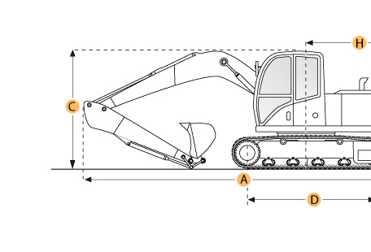

Selected Dimensions

Boom/Stick Option
A. Shipping Length of Unit | 23.5 ft in | 7170 mm
C. Shipping Height of Unit | 8.9 ft in | 2715 mm
I. Max Cutting Height | 25.4 ft in | 7745 mm
J. Max Loading Height | 17.9 ft in | 5470 mm
K. Max Reach Along Ground | 24 ft in | 7315 mm
L. Max Vertical Wall Digging Depth | 14 ft in | 4270 mm
M. Max Digging Depth | 15.6 ft in | 4760 mm
Dimensions
B. Width to Outside of Tracks | 8.1 ft in | 2460 mm
D. Length of Track on Ground | 8.4 ft in | 2575 mm
E. Ground Clearance | 1.3 ft in | 400 mm
G. Height to Top of Cab | 8.9 ft in | 2715 mm
H. Tail Swing Radius | 7 ft in | 2130 mm
O. Counterweight Clearance | 2.8 ft in | 855 mm
Undercarriage
F. Track Gauge | 6.4 ft in | 1960 mm
N. Shoe Size | 19.7 in | 500 mm

Specification
Engine
Make | Komatsu
Model | S4D102E
Gross Power | 80.5 hp | 60 kw
Power Measured @ | 2100 rpm
Displacement | 239.2 cu in | 3.9 L
Number of Cylinders | 4
Operational
Operating Weight | 23699.7 lb | 10750 kg
Fuel Capacity | 60.8 gal | 230 L
Hydrauilc System Fluid Capacity | 26.4 gal | 100 L
Hydraulic System Relief Valve Pressure | 4620 psi | 31853.8 kPa
Hydraulic Pump Flow Capacity | 57.1 gal/min | 216 L/min
Swing Mechanism
Swing Speed | 12 rpm
Undercarriage
Shoe Size | 19.7 in | 500 mm
Ground Pressure | 5.4 psi | 37.2 kPa
Max Travel Speed | 3.4 mph | 5.5 km/h
Track Gauge | 6.4 ft in | 1960 mm
Buckets
Reference Bucket Capacity | 0.58 yd3 | 0.44 m3
Minimum Bucket Capacity | 0.24 yd3 | 0.18 m3
Maximum Bucket Capacity | 0.72 yd3 | 0.55 m3
Boom/Stick Option (HEX) 1
Boom/Stick Option (HEX) 1 | Boom 14'0" (4260mm)/Stick 6'9" (2060mm)
Shipping Height of Unit | 8.9 ft in | 2715 mm
Shipping Length of Unit | 23.5 ft in | 7170 mm
Max Digging Depth | 15.6 ft in | 4760 mm
Max Reach Along Ground | 24 ft in | 7315 mm
Max Cutting Height | 25.4 ft in | 7745 mm
Max Loading Height | 17.9 ft in | 5470 mm
Max Vertical Wall Digging Depth | 14 ft in | 4270 mm
Boom/Stick Option (HEX) 2
Boom/Stick Option (HEX) 2 | Boom 14'0" (4260mm)/Stick 7'9" (2360mm)
Shipping Height of Unit | 8.9 ft in | 2725 mm
Shipping Length of Unit | 23.5 ft in | 7170 mm
Max Digging Depth | 16.6 ft in | 5060 mm
Max Reach Along Ground | 24.9 ft in | 7590 mm
Max Cutting Height | 26.1 ft in | 7970 mm
Max Loading Height | 18.7 ft in | 5700 mm
Max Vertical Wall Digging Depth | 14.8 ft in | 4500 mm
Boom/Stick Option (HEX) 3
Boom/Stick Option (HEX) 3 | Boom 14'0" (4260mm)/Stick 9'5" (2860mm)
Shipping Height of Unit | 10.1 ft in | 3080 mm
Shipping Length of Unit | 23.2 ft in | 7085 mm
Max Digging Depth | 18.2 ft in | 5560 mm
Max Reach Along Ground | 26.3 ft in | 8025 mm
Max Cutting Height | 26.5 ft in | 8080 mm
Max Loading Height | 19.1 ft in | 5825 mm
Max Vertical Wall Digging Depth | 16.8 ft in | 5125 mm
Dimensions
Width to Outside of Tracks | 8.1 ft in | 2460 mm
Height to Top of Cab | 8.9 ft in | 2715 mm
Ground Clearance | 1.3 ft in | 400 mm
Counterweight Clearance | 2.8 ft in | 855 mm
Tail Swing Radius | 7 ft in | 2130 mm
Length of Track on Ground | 8.4 ft in | 2575 mm

