The 'Invincible II' chassis
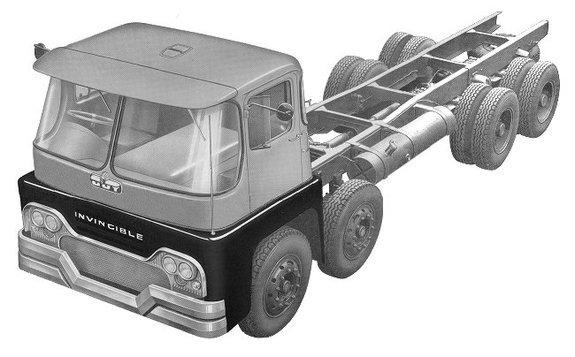

The 8-wheel 'Invincible II' chassis. Courtesy of Brian Shaw.

The 'Invincible II' range consisted of heavy duty versions of the 'Warrior II' series, capable of transporting heavier loads, while still retaining the same high degree of driver comfort, and ease of operation.
Specification:
Engine
Two options were available as standard:
a) 9.8 litre, 6-cylinder, 125 b.h.p. at 1,800 r.p.m., torque 410 lb. ft. at 900 r.p.m.
b) 11.1 litre, 6-cylinder, 150 b.h.p. at 2,000 r.p.m., torque 450 lb. ft. at 1,100 r.p.m.
Alternative engines of up to 220 b.h.p. were also available.
Clutch
Large diameter, hydraulically operated.
Gearbox
6-speed, constant mesh, with overdrive on top gear. Provision was made for a power take-off.
Ratios: 1st 6.63 to 1, 2nd 3.88 to 1, 3rd 2.43 to 1, 4th 1.55 to 1, 5th 1 to 1, 6th 0.71 to 1, reverse 5.66 to 1.
Alternative 6, 10, or 12-speed gearboxes were available.
Transmission
Open tubular prop-shafts with needle roller universal joints.
Front axle
Extra heavy duty ‘I’ section forged steel beam. Maximum carrying capacity 5½ tons.
Rear axle
Several alternatives were used, depending upon the size of the vehicle.
20 tons g.t.w. - 17" diameter, spiral bevel wheel and pinion, ratio 6.14 to 1.
25 tons g.t.w. - 8½" centres, worm and wheel, ratio 7.25 to 1.
36 tons g.t.w. - double reduction, double helical, spiral bevel wheel and pinion, ratio 7.01 to 1.
6 and 8 wheeled models:
25 tons g.t.w. - single axle drive, trailing rear axle (4 spring bogie), 8½" centres, worm and wheel, ratio 7.25 to 1.
36 tons g.t.w. - double reduction, double helical gear and spiral bevel, ratio 7.01 to 1, wheel and pinion.
Two axle drive:
45 tons g.t.w. - 8½" centres, worm and wheel on both axles, ratio 7.25 to 1.
Steering
Available with left or right hand steering. Cam and double roller, ratio 28.5 to 1.
Brakes
Bendix-Westinghouse dual air brake system, low pressure warning buzzer incorporated. Multi-pull handbrake giving high efficiency under full load, with air pressure assistance as an optional extra.
Suspension
Exceptionally long 4" wide, semi-elliptic springs, 50 inches long at the front, 60 inches long at the rear.
Wheels and Tyres
Forward control:
4-wheeled models and 6-wheeled twin-steer models, 10.00 x 20 tyres on B7.0 wheels.
6-wheeled models (except tractor), front 10.00 x 20 tyres on B7.0 wheels, rear 9.00 x 20 tyres on B6.S wheels.
8-wheeled models and 6-wheeled tractor, 9.00 x 20 tyres on B6.S wheels.
Bonneted:
4 and 6-wheeled models, 10.00 x 20 tyres on B7.0 wheels.
Frame
Channel section, carbon manganese steel pressings, 12" deep x 3" wide. 4-wheeled 8 ft. 9 inch and 17 ft. 9 inch wheelbase models were fitted with 0.1875 inch thick side members. Frame thickness on all other models was 0.312 inch. Front and rear facilities were available as optional extras.
Electrical
24 volt lighting and starting equipment insulated return with compensated voltage control. Batteries supplied in four 6 volt units, capacity being 102 ampere hours.
Fuel tank
Cylindrical welded steel tank, capacity50 gallons. Larger capacities were available on request.
Cab
The cab assembly was in two sections, split at a flat waist line. The top was easily removable for maintenance etc. Fittings included a full-width visor, twin air operated windscreen washers, electrically operated wipers, twin interior lights, twin seats, fully adjustable driving seat, and twin telescopic mirrors. Optional extras included a large fresh air heating and ventilating unit, external double skin roof, roof ventilator, and an interior sun visor for the passenger.

