Terex RH400 Shovel
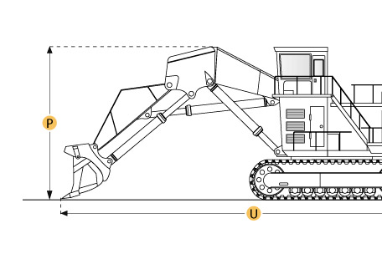

Selected Dimensions
Dimensions
B. Width Over Tracks | 28.2 ft in | 8600 mm
D. Length of Track on Ground | 27.7 ft in | 8445 mm
E. Ground Clearance | 3.7 in | 1135 mm
G. Height to Top of Cab | 33.4 ft in | 10175 mm
Loading Shovel
Q. Max Cutting Height | 66.3 ft in | 20200 mm
R. Max Dump Height | 47.6 ft in | 14500 mm
S. Max Dig Reach | 62.3 ft in | 19000 mm
T. Max Dig Depth | 7.5 ft in | 2300 mm
Undercarriage
F. Track Gauge | 21.7 ft in | 6600 mm
N. Loading Shovel Shoe Width | 78.7 in | 2000 mm

Specification
Engine
Make | Cummins
Model | 2 x QSK 60-C
Gross Power | 4500 hp | 3355.6 kw
Net Power | 4500 hp | 3355.6 kw
Power Measured @ | 1800 rpm
Displacement | 4210 cu in | 69 L
Aspiration | Turbocharged and aftercooled
Number of Cylinders | 16
Operational
Fuel Capacity | 4226.8 gal | 16000 L
Hydraulic System Fluid Capacity | 2641.7 gal | 10000 L
Swing Speed | 4.4 rpm
Operating Voltage | 24 V
Alternator Supplied Amperage | 350 amps
Undercarriage
Max Travel Speed | 1.4 mph | 2.2 km/h
Number of Upper Rollers | 2
Number of Lower Rollers | 7
Number of Track Shoes per Side | 48
Track Gauge | 21.7 ft in | 6600 mm
Loading Shovel Shoe Width | 78.7 in | 2000 mm
Loading Shovel Operating Weight | 2160530.3 lb | 980000 kg
Loading Shovel Ground Pressure | 30.7 psi | 211.7 kPa
Loading Shovel
Loading Shovel | boom 31'2" (9500mm) w/ stick 18'4" (5600mm)
Max Dig Depth | 7.5 ft in | 2300 mm
Max Cutting Height | 66.3 ft in | 20200 mm
Max Dump Height | 47.6 ft in | 14500 mm
Max Dig Reach | 62.3 ft in | 19000 mm
Buckets
Reference Bucket Capacity | 58.9 yd3 | 45 m3
Dimensions
Width Over Tracks | 28.2 ft in | 8600 mm
Height to Top of Cab | 33.4 ft in | 10175 mm
Length of Tracks | 36 ft in | 10980 mm
Length of Track on Ground | 27.7 ft in | 8445 mm
Ground Clearance | 3.7 in | 1135 mm
Upper Structure Ground Clearance | 10.3 ft in | 3150 mm
Height of Tracks | 9.7 ft in | 2945 mm

