Komatsu PC650-1 Shovel
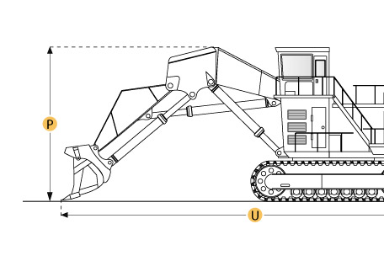

Selected Dimensions
Dimensions
B. Width Over Tracks | ft in | 3910 mm
D. Length of Track on Ground | 14.8 ft in | 4510 mm
E. Ground Clearance | 2 in | 620 mm
G. Height to Top of Cab | 14.5 ft in | 4430 mm
Loading Shovel
Q. Max Cutting Height | 34.8 ft in | 10600 mm
R. Max Dump Height | 24.5 ft in | 7460 mm
S. Max Dig Reach | 32.8 ft in | 10000 mm
T. Max Dig Depth | 11.5 ft in | 3500 mm
Undercarriage
N. Loading Shovel Shoe Width | 24 in | 610 mm

Specification
Engine
Make | Komatsu
Model | Cummins KT-1150-C450
Gross Power | 410 hp | 305.7 kw
Displacement | 1150 cu in | 18.8 L
Aspiration | turbocharged
Operational
Fuel Capacity | 224.5 gal | 850 L
Hydraulic System Fluid Capacity | 118.9 gal | 450 L
Swing Speed | 4.3 rpm
Undercarriage
Max Travel Speed | 2.5 mph | 4.1 km/h
Loading Shovel Shoe Width | 24 in | 610 mm
Loading Shovel Operating Weight | 151016.7 lb | 68500 kg
Loading Shovel Ground Pressure | 15.9 psi | 109.6 kPa
Loading Shovel
Loading Shovel | Boom 15'5" (4690mm)/Stick 10'6" (3210mm)
Max Dig Depth | 11.5 ft in | 3500 mm
Max Cutting Height | 34.8 ft in | 10600 mm
Max Dump Height | 24.5 ft in | 7460 mm
Max Dig Reach | 32.8 ft in | 10000 mm
Arm Crowd Force | 99210 lb ft | 441 Nm
Dimensions
Width Over Tracks | ft in | 3910 mm
Height to Top of Cab | 14.5 ft in | 4430 mm
Length of Tracks | 18.9 ft in | 5765 mm
Length of Track on Ground | 14.8 ft in | 4510 mm
Ground Clearance | 2 in | 620 mm
Upper Structure Ground Clearance | 3.9 ft in | 1175 mm

