Terex RH200 Shovel
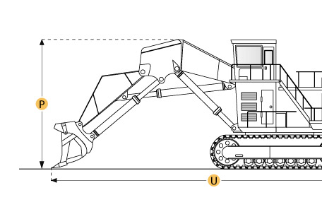

Selected Dimensions
Dimensions
B. Width Over Tracks | 23 ft in | 7000 mm
D. Length of Track on Ground | 21 ft in | 6400 mm
E. Ground Clearance | 3.7 in | 1120 mm
G. Height to Top of Cab | 28.7 ft in | 8760 mm
Loading Shovel
Q. Max Cutting Height | 50.2 ft in | 15300 mm
R. Max Dump Height | 38.7 ft in | 11800 mm
S. Max Dig Reach | 53.1 ft in | 16200 mm
T. Max Dig Depth | 7.9 ft in | 2400 mm
Undercarriage
F. Track Gauge | 18.4 ft in | 5600 mm
N. Loading Shovel Shoe Width | 55.1 in | 1400 mm

Specification
Engine
Make | Cummins
Model | 2x K 1500-E
Gross Power | 2520 hp | 1879.2 kw
Net Power | 2520 hp | 1879.2 kw
Power Measured @ | 1800 rpm
Displacement | 2300 cu in | 37.7 L
Aspiration | Turbocharged and aftercooled
Number of Cylinders | 24
Operational
Fuel Capacity | 2820 gal | 10674.9 L
Hydraulic System Fluid Capacity | 1611.4 gal | 6100 L
Swing Speed | 3.9 rpm
Operating Voltage | 24 V
Alternator Supplied Amperage | 350 amps
Undercarriage
Max Travel Speed | 2.3 mph | 3.7 km/h
Number of Upper Rollers | 2
Number of Lower Rollers | 6
Number of Track Shoes per Side | 39
Track Gauge | 18.4 ft in | 5600 mm
Backhoe Shoe Width 1 | 55.1 in | 1400 mm
Backhoe Operating Weight - Shoe 1 | 1183882.4 lb | 537000 kg
Backhoe Ground Pressure - Shoe 1 | 38.1 psi | 262.7 kPa
Loading Shovel Shoe Width | 55.1 in | 1400 mm
Loading Shovel Operating Weight | 1157426.8 lb | 525000 kg
Loading Shovel Ground Pressure | 37.3 psi | 257.2 kPa
Backhoe Boom / Stick 1
Backhoe Boom / Stick | boom 34'5" (10500mm) w/ stick 18'1" (5500mm)
Max Dig Depth | 30.2 ft in | 9200 mm
Max Cutting Height | 55.8 ft in | 17000 mm
Loading Shovel
Loading Shovel | boom 26'2" (8000mm) w/ stick 16'9" (5100mm)
Max Dig Depth | 7.9 ft in | 2400 mm
Max Cutting Height | 50.2 ft in | 15300 mm
Max Dump Height | 38.7 ft in | 11800 mm
Max Dig Reach | 53.1 ft in | 16200 mm
Buckets
Reference Bucket Capacity | 27.5 yd3 | 21 m3
Minimum Bucket Capacity | 27.5 yd3 | 21 m3
Maximum Bucket Capacity | 39.9 yd3 | 30.5 m3
Dimensions
Width Over Tracks | 23 ft in | 7000 mm
Height to Top of Cab | 28.7 ft in | 8760 mm
Length of Tracks | 28 ft in | 8540 mm
Length of Track on Ground | 21 ft in | 6400 mm
Ground Clearance | 3.7 in | 1120 mm
Upper Structure Ground Clearance | 9.1 ft in | 2780 mm
Height of Tracks | 8.1 ft in | 2480 mm

