Komatsu PC100 Hydraulic Excavator
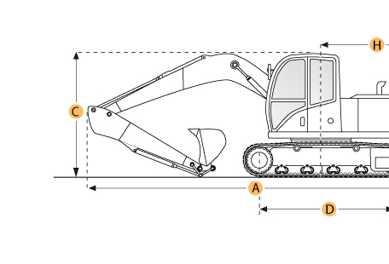

Selected Dimensions

Boom/Stick Option
A. Shipping Length of Unit | 23.6 ft in | 7180 mm
I. Max Cutting Height | 23.5 ft in | 7170 mm
J. Max Loading Height | 16.3 ft in | 4980 mm
K. Max Reach Along Ground | 23.5 ft in | 7170 mm
L. Max Vertical Wall Digging Depth | 12.9 ft in | 3920 mm
M. Max Digging Depth | 15.1 ft in | 4600 mm
Dimensions
B. Width to Outside of Tracks | 7.5 ft in | 2300 mm
D. Length of Track on Ground | 7.7 ft in | 2340 mm
E. Ground Clearance | 1.3 ft in | 400 mm
G. Height to Top of Cab | 8.8 ft in | 2675 mm
H. Tail Swing Radius | 7.3 ft in | 2225 mm
O. Counterweight Clearance | 3 ft in | 910 mm
Undercarriage
F. Track Gauge | 6 ft in | 1820 mm
N. Shoe Size | 18.9 in | 480 mm

Specification
Engine
Make | Komatsu
Model | S4D 105-5
Gross Power | 81 hp | 60.4 kw
Displacement | 264 cu in | 4.3 L
Operational
Operating Weight | 23148 lb | 10499.8 kg
Fuel Capacity | 60.8 gal | 230 L
Hydrauilc System Fluid Capacity | 38.3 gal | 145 L
Hydraulic System Relief Valve Pressure | 2500 psi | 17236.9 kPa
Hydraulic Pump Flow Capacity | 65.5 gal/min | 248 L/min
Swing Mechanism
Swing Speed | 10 rpm
Undercarriage
Shoe Size | 18.9 in | 480 mm
Ground Pressure | 6 psi | 41.2 kPa
Max Travel Speed | 2.1 mph | 3.4 km/h
Track Gauge | 6 ft in | 1820 mm
Boom/Stick Option (HEX) 1
Boom/Stick Option (HEX) 1 | Boom 14'0" (4260mm)/Stick 6'7" (2002mm)
Shipping Length of Unit | 23.6 ft in | 7180 mm
Max Digging Depth | 15.1 ft in | 4600 mm
Max Reach Along Ground | 23.5 ft in | 7170 mm
Max Cutting Height | 23.5 ft in | 7170 mm
Max Loading Height | 16.3 ft in | 4980 mm
Max Vertical Wall Digging Depth | 12.9 ft in | 3920 mm
Boom/Stick Option (HEX) 2
Boom/Stick Option (HEX) 2 | Boom 14'0" (4260mm)/Stick 7'10" (2400mm)
Max Digging Depth | 16.4 ft in | 5000 mm
Max Reach Along Ground | 24.7 ft in | 7530 mm
Max Cutting Height | 23.9 ft in | 7290 mm
Max Loading Height | 16.8 ft in | 5110 mm
Max Vertical Wall Digging Depth | 13.8 ft in | 4220 mm
Boom/Stick Option (HEX) 3
Boom/Stick Option (HEX) 3 | Boom 14'0" (4260mm)/Stick 9'4" (2850mm)
Max Digging Depth | 17.9 ft in | 5450 mm
Max Reach Along Ground | 26 ft in | 7920 mm
Max Cutting Height | 24.2 ft in | 7380 mm
Max Loading Height | 17.1 ft in | 5210 mm
Max Vertical Wall Digging Depth | 15 ft in | 4560 mm
Dimensions
Width to Outside of Tracks | 7.5 ft in | 2300 mm
Height to Top of Cab | 8.8 ft in | 2675 mm
Ground Clearance | 1.3 ft in | 400 mm
Counterweight Clearance | 3 ft in | 910 mm
Tail Swing Radius | 7.3 ft in | 2225 mm
Length of Track on Ground | 7.7 ft in | 2340 mm

