Caterpillar 225 Hydraulic Excavator
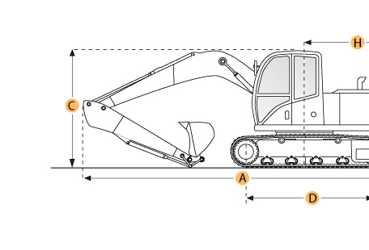

Selected Dimensions

Boom/Stick Option
I. Max Cutting Height | 28.2 ft in | 8600 mm
J. Max Loading Height | 19.1 ft in | 5820 mm
K. Max Reach Along Ground | 30.3 ft in | 9240 mm
L. Max Vertical Wall Digging Depth | 12.2 ft in | 3710 mm
M. Max Digging Depth | 19.6 ft in | 5970 mm
Dimensions
B. Width to Outside of Tracks | 10.3 ft in | 3125 mm
D. Length of Track on Ground | 12.8 ft in | 3916 mm
E. Ground Clearance | 1.2 ft in | 368 mm
G. Height to Top of Cab | 10.4 ft in | 3175 mm
H. Tail Swing Radius | 9.2 ft in | 2794 mm
O. Counterweight Clearance | 3.4 ft in | 1040 mm
Undercarriage
F. Track Gauge | 8 ft in | 2440 mm
N. Shoe Size | 21.7 in | 550 mm

Specification
Engine
Model | 3208
Gross Power | 135 hp | 100.7 kw
Displacement | 634.6 cu in | 10.4 L
Operational
Operating Weight | 51599.2 lb | 23405 kg
Fuel Capacity | 65 gal | 246 L
Hydraulic System Relief Valve Pressure | 1000 psi | 6894.8 kPa
Hydraulic Pump Flow Capacity | 111.8 gal/min | 423.2 L/min
Swing Mechanism
Swing Speed | 2.3 rpm
Undercarriage
Shoe Size | 21.7 in | 550 mm
Drawbar Pull | 36700 lb | 163.2 kN
Track Gauge | 8 ft in | 2440 mm
Boom/Stick Option (HEX) 1
Boom/Stick Option (HEX) 1 | one piece boom w/ stick 1900mm
Max Digging Depth | 19.6 ft in | 5970 mm
Max Reach Along Ground | 30.3 ft in | 9240 mm
Max Cutting Height | 28.2 ft in | 8600 mm
Max Loading Height | 19.1 ft in | 5820 mm
Max Vertical Wall Digging Depth | 12.2 ft in | 3710 mm
Boom/Stick Option (HEX) 2
Boom/Stick Option (HEX) 2 | one piece boom w/ stick 2440mm
Max Digging Depth | 21.3 ft in | 6480 mm
Max Reach Along Ground | 31.4 ft in | 9580 mm
Max Cutting Height | 27.1 ft in | 8260 mm
Max Loading Height | 19 ft in | 5790 mm
Max Vertical Wall Digging Depth | 12.6 ft in | 3840 mm
Boom/Stick Option (HEX) 3
Boom/Stick Option (HEX) 3 | one piece boom w/ stick 3060mm
Max Digging Depth | 23.1 ft in | 7040 mm
Max Reach Along Ground | 33.3 ft in | 10160 mm
Max Cutting Height | 28.6 ft in | 8710 mm
Max Loading Height | 19.7 ft in | 5990 mm
Max Vertical Wall Digging Depth | 13.5 ft in | 4110 mm
Dimensions
Width to Outside of Tracks | 10.3 ft in | 3125 mm
Height to Top of Cab | 10.4 ft in | 3175 mm
Ground Clearance | 1.2 ft in | 368 mm
Counterweight Clearance | 3.4 ft in | 1040 mm
Tail Swing Radius | 9.2 ft in | 2794 mm
Length of Track on Ground | 12.8 ft in | 3916 mm

