KOMATSU pc1100lc-6 Hydraulic Excavator
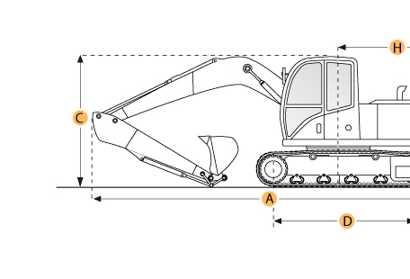

Selected Dimensions Boom/Stick Option
A. Shipping Length of Unit | 52.6 ft in | 16020 mm
C. Shipping Height of Unit | 19.8 ft in | 6040 mm
I. Max Cutting Height | 44 ft in | 13400 mm
J. Max Loading Height | 28.5 ft in | 8680 mm
K. Max Reach Along Ground | 49.2 ft in | 15000 mm
L. Max Vertical Wall Digging Depth | 25 ft in | 7610 mm
M. Max Digging Depth | 30.7 ft in | 9350 mm
Dimensions
B. Width to Outside of Tracks | 15.1 ft in | 4600 mm
D. Length of Track on Ground | 19.6 ft in | 5970 mm
E. Ground Clearance | 3.2 ft in | 990 mm
G. Height to Top of Cab | 12.6 ft in | 3855 mm
H. Tail Swing Radius | 16 ft in | 4870 mm
O. Counterweight Clearance | 5.9 ft in | 1790 mm
Undercarriage
F. Track Gauge | 12.8 ft in | 3900 mm
N. Shoe Size | 39.4 in | 1000 mm

Specification
Engine
Make | Komatsu
Model | SAA6D170E
Gross Power | 611.5 hp | 456 kw
Power Measured @ | 1800 rpm
Displacement | 1412.7 cu in | 23.2 L
Number of Cylinders | 6
Operational
Operating Weight | 244713.1 lb | 111000 kg
Fuel Capacity | 359.3 gal | 1360 L
Hydrauilc System Fluid Capacity | 177 gal | 670 L
Hydraulic System Relief Valve Pressure | 4550 psi | 31371.1 kPa
Hydraulic Pump Flow Capacity | 419.5 gal/min | 1588 L/min
Swing Mechanism
Swing Speed | 5.8 rpm
Undercarriage
Shoe Size | 39.4 in | 1000 mm
Ground Pressure | 12.2 psi | 84.1 kPa
Max Travel Speed | 2 mph | 3.2 km/h
Track Gauge | 12.8 ft in | 3900 mm
Buckets
Reference Bucket Capacity | 6.5 yd3 | 5 m3
Minimum Bucket Capacity | 4.4 yd3 | 3.4 m3
Maximum Bucket Capacity | 6.5 yd3 | 5 m3
Boom/Stick Option (HEX) 1
Boom/Stick Option (HEX) 1 | Boom 29'10" (9100mm)/Stick 11'2" (3400mm)
Shipping Height of Unit | 19.8 ft in | 6040 mm
Shipping Length of Unit | 52.6 ft in | 16020 mm
Max Digging Depth | 30.7 ft in | 9350 mm
Max Reach Along Ground | 49.2 ft in | 15000 mm
Max Cutting Height | 44 ft in | 13400 mm
Max Loading Height | 28.5 ft in | 8680 mm
Max Vertical Wall Digging Depth | 25 ft in | 7610 mm
Boom/Stick Option (HEX) 2
Boom/Stick Option (HEX) 2 | Boom 29'10" (9100mm)/Stick 14'9" (4500mm)
Shipping Height of Unit | 21.2 ft in | 6460 mm
Shipping Length of Unit | 52.7 ft in | 16050 mm
Max Digging Depth | 34.3 ft in | 10440 mm
Max Reach Along Ground | 52.5 ft in | 16000 mm
Max Cutting Height | 44.3 ft in | 13490 mm
Max Loading Height | 29.5 ft in | 9000 mm
Max Vertical Wall Digging Depth | 27.9 ft in | 8490 mm
Boom/Stick Option (HEX) 3
Boom/Stick Option (HEX) 3 | Boom 29'10" (9100mm)/Stick 18'8" (5700mm)
Shipping Height of Unit | 22.9 ft in | 6990 mm
Shipping Length of Unit | 52 ft in | 15840 mm
Max Digging Depth | 38 ft in | 11590 mm
Max Reach Along Ground | 56.2 ft in | 17130 mm
Max Cutting Height | 45.6 ft in | 13910 mm
Max Loading Height | 31 ft in | 9440 mm
Max Vertical Wall Digging Depth | 31.1 ft in | 9480 mm
Dimensions
Width to Outside of Tracks | 15.1 ft in | 4600 mm
Height to Top of Cab | 12.6 ft in | 3855 mm
Ground Clearance | 3.2 ft in | 990 mm
Counterweight Clearance | 5.9 ft in | 1790 mm
Tail Swing Radius | 16 ft in | 4870 mm
Length of Track on Ground | 19.6 ft in | 5970 mm

