Bell HD820 Mark 3 Hydraulic Excavator

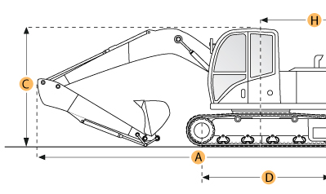

Selected Dimensions
Boom/Stick Option (HEX) 1
I. Max Cutting Height | 15.9 ft in | 4850 mm
J. Max Loading Height | 20.9 ft in | 6380 mm
K. Max Reach Along Ground | 28.9 ft in | 8820 mm
M. Max Digging Depth | 18.6 ft in | 5680 mm
Dimensions
B. Width to Outside of Tracks | 9.3 ft in | 2820 mm
D. Length of Track on Ground | 11.1 ft in | 3370 mm
E. Ground Clearance | 1.5 ft in | 465 mm
H. Tail Swing Radius | 9 ft in | 2750 mm
Undercarriage
N. Shoe Size | 23.6 in | 600 mm

Specification
Engine
Make | Mitsubishi
Model | C 6D34-TLE 2A
Gross Power | 147.5 hp | 110 kw
Operational
Operating Weight | 43431.1 lb | 19700 kg
Hydraulic System Relief Valve Pressure | 4771.7 psi | 32900 kPa
Hydraulic Pump Flow Capacity | 124.2 gal/min | 470 L/min
Undercarriage
Shoe Size | 23.6 in | 600 mm
Boom/Stick Option (HEX) 1
Boom/Stick Option (HEX) 1 | standard
Max Digging Depth | 18.6 ft in | 5680 mm
Max Reach Along Ground | 28.9 ft in | 8820 mm
Max Cutting Height | 15.9 ft in | 4850 mm
Max Loading Height | 20.9 ft in | 6380 mm
Dimensions
Width to Outside of Tracks | 9.3 ft in | 2820 mm
Ground Clearance | 1.5 ft in | 465 mm
Tail Swing Radius | 9 ft in | 2750 mm
Length of Track on Ground | 11.1 ft in | 3370 mm

