Caterpillar 365C FS Shovel

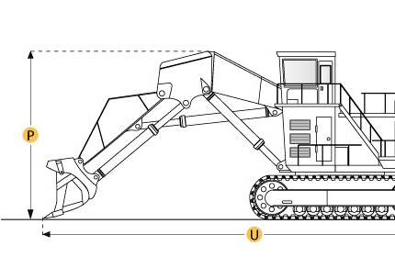

Selected Dimensions
Dimensions
B. Width Over Tracks | 12.8 ft in | 3900 mm
E. Ground Clearance | 2.8 in | 840 mm
G. Height to Top of Cab | 15 ft in | 4570 mm
H. Tail Swing Radius | 13.2 ft in | 4020 mm
Undercarriage
F. Track Gauge | 10.7 ft in | 3250 mm

Specification
Engine
Make | Caterpillar
Model | C15 Diesel engine with ACERT techonlogy
Net Power | 411 hp | 306.5 kw
Power Measured @ | 1800 rpm
Displacement | 927.6 cu in | 15.2 L
Operational
Fuel Capacity | 211.3 gal | 800 L
Cooling System Fluid Capacity | 25.1 gal | 95 L
Engine Oil Capacity | 14.3 gal | 54 L
Hydraulic System Fluid Capacity | 177 gal | 670 L
Swing Speed | 6.5 rpm
Alternator Supplied Amperage | 75 amps
Undercarriage
Max Travel Speed | 2.5 mph | 4.1 km/h
Number of Upper Rollers | 3
Number of Lower Rollers | 8
Number of Track Shoes per Side | 47
Track Gauge | 10.7 ft in | 3250 mm
Backhoe Shoe Width 1 | 25.6 in | 650 mm
Backhoe Shoe Width 2 | 24 in | 610 mm
Backhoe Shoe Width 3 | 29.5 in | 750 mm
Backhoe Operating Weight - Shoe 1 | 163803.5 lb | 74300 kg
Tail Swing Radius | 13.2 ft in | 4020 mm
Dimensions
Width Over Tracks | 12.8 ft in | 3900 mm
Height to Top of Cab | 15 ft in | 4570 mm
Length of Tracks | 19.2 ft in | 5860 mm
Ground Clearance | 2.8 in | 840 mm
Upper Structure Ground Clearance | 5.1 ft in | 1540 mm
Tail Swing Radius | 13.2 ft in | 4020 mm

