Komatsu HD785-1 Rock Truck
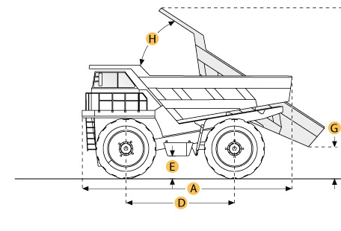

Selected Dimensions
Dimensions
A. Overall Length | 33.2 ft in | 10130 mm
B. Overall Width | 16.4 ft in | 5000 mm
C. Overall Height | 16 ft in | 4870 mm
D. Wheelbase | 15.6 ft in | 4750 mm
E. Ground Clearance | 2.6 ft in | 780 mm
F. Dump Height | 29.5 ft in | 9000 mm
G. Dump Ground Clearance | 3 ft in | 900 mm
Dump
H. Dump Angle | 64 degrees

Specification
Engine
Make | Cummins
Model | KT-2300
Gross Power | 900 hp | 671.1 kw
Net Power | 877 hp | 654 kw
Displacement | 2306.7 cu in | 37.8 L
Aspiration | turbocharged
Operational
Fuel Capacity | 327.6 gal | 1240 L
Cooling System Fluid Capacity | 63.4 gal | 240 L
Engine Oil Capacity | 39.6 gal | 150 L
Diff and Final Drive Fluid Capacity | 59.2 gal | 224 L
Hydraulic System Fluid Capacity | 121.5 gal | 460 L
Tire Size | 24.00-49-42PR
Transmission
Type | Komatsu TORQFLOW planetary gear
Number of Gears - Forward | 6
Number of Gears - Reverse | 1
Max Speed | 43.5 mph | 70 km/h
Weights
Empty Weight | 113538.1 lb | 51500 kg
Loaded Weight | 285619.9 lb | 129555 kg
Weight Distribution Front - empty | 48.2 %
Weight Distribution Rear - empty | 51.8 %
Weight Distribution Front - loaded | 32.3 %
Weight Distribution Rear - loaded | 67.7 %
Dump
Rated Payload | 171960.6 lb | 78000 kg
Load Capacity - heaped | 67.8 yd3 | 51.8 m3
Dump Angle | 64 degrees
Dimensions
Overall Length | 33.2 ft in | 10130 mm
Overall Width | 16.4 ft in | 5000 mm
Overall Height | 16 ft in | 4870 mm
Wheelbase | 15.6 ft in | 4750 mm
Ground Clearance | 2.6 ft in | 780 mm
Dump Height | 29.5 ft in | 9000 mm
Dump Ground Clearance | 3 ft in | 900 mm

