Caterpillar 772 Rock Truck
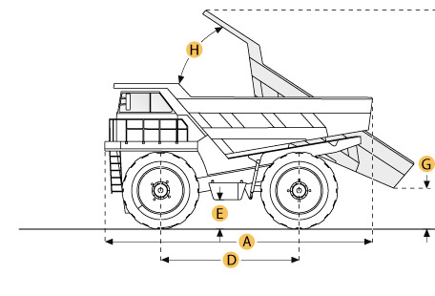

Selected Dimensions
Dimensions
A. Overall Length | 28.8 ft in | 8740 mm
B. Overall Width | 15.7 ft in | 4780 mm
C. Overall Height | 14 ft in | 4265 mm
D. Wheelbase | 13 ft in | 3960 mm
E. Ground Clearance | 2.4 ft in | 720 mm
F. Dump Height | 27.4 ft in | 8357 mm
G. Dump Ground Clearance | 1.8 ft in | 560 mm

Specification
Engine
Make | Caterpillar
Model | C18 ACERT
Gross Power | 598 hp | 446 kw
Net Power | 535 hp | 399 kw
Power Measured @ | 1800 rpm
Displacement | 1105 cu in | 18.1 L
Max Torque | 1988 lb ft | 2695.4 Nm
Number of Cylinders | 6
Aspiration | Turbocharged
Operational
Fuel Capacity | 140 gal | 530 L
Cooling System Fluid Capacity | 30 gal | 114 L
Engine Oil Capacity | 14 gal | 53 L
Diff and Final Drive Fluid Capacity | 42 gal | 159 L
Steering System Fluid Capacity | 15 gal | 56 L
Brake/Hoist System Fluid Capacity | 73 gal | 277 L
Hydraulic System Fluid Capacity | 35 gal | 155 L
Tire Size | 21.00R33(E4)
Transmission
Type | Gear
Number of Gears - Forward | 7
Number of Gears - Reverse | 1
Max Speed | 49.5 mph | 79.7 km/h
Weights
Empty Weight | 78155 lb | 35450 kg
Loaded Weight | 181000 lb | 82100 kg
Weight Distribution Front - empty | 48 %
Weight Distribution Rear - empty | 52 %
Weight Distribution Front - loaded | 34 %
Weight Distribution Rear - loaded | 66 %
Dump
Rated Payload | 100000 lb | 45359.2 kg
Load Capacity - Struck | 30.5 yd3 | 23.3 m3
Load Capacity - heaped | 41 yd3 | 31.3 m3
Raise Time | 8.1 sec
Lower Time | 14.7 sec
Dimensions
Overall Length | 28.8 ft in | 8740 mm
Overall Width | 15.7 ft in | 4780 mm
Overall Height | 14 ft in | 4265 mm
Wheelbase | 13 ft in | 3960 mm
Ground Clearance | 2.4 ft in | 720 mm
Dump Height | 27.4 ft in | 8357 mm
Dump Ground Clearance | 1.8 ft in | 560 mm

