Caterpillar 769d Rock Truck
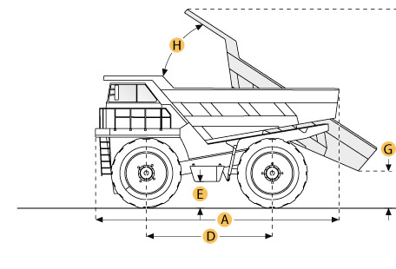

Selected Dimensions
Dimensions
A. Overall Length | 26.4 ft in | 8039 mm
B. Overall Width | 12.8 ft in | 3910 mm
C. Overall Height | 12.1 ft in | 3690 mm
D. Wheelbase | 12.2 ft in | 3713 mm
E. Ground Clearance | 2.1 ft in | 627 mm
F. Dump Height | 25.4 ft in | 7751 mm
G. Dump Ground Clearance | 1.5 ft in | 465 mm
Dump
H. Dump Angle | 60 degrees

Specification
Engine
Make | Caterpillar
Model | 3408ETA
Gross Power | 510 hp | 380.3 kw
Net Power | 485 hp | 361.7 kw
Power Measured @ | 2000 rpm
Displacement | 1098.4 cu in | 18 L
Max Torque | 1618.2 lb ft | 2194 Nm
Operational
Fuel Capacity | 140 gal | 530 L
Cooling System Fluid Capacity | 30 gal | 113.5 L
Engine Oil Capacity | 11.9 gal | 45 L
Diff and Final Drive Fluid Capacity | 21.9 gal | 83 L
Steering System Fluid Capacity | 14.8 gal | 56 L
Brake/Hoist System Fluid Capacity | 73.2 gal | 277 L
Hydraulic System Fluid Capacity | 40.9 gal | 155 L
Tire Size | 18-R33
Transmission
Number of Gears - Forward | 8
Number of Gears - Reverse | 1
Max Speed | 48.3 mph | 77.7 km/h
Weights
Empty Weight | 78087.7 lb | 35420 kg
Loaded Weight | 157410 lb | 71400 kg
Weight Distribution Front - empty | 49.7 %
Weight Distribution Rear - empty | 50.3 %
Weight Distribution Front - loaded | 33.2 %
Weight Distribution Rear - loaded | 66.8 %
Dump
Rated Payload | 79000 lb | 35833.8 kg
Load Capacity - Struck | 22.2 yd3 | 17 m3
Load Capacity - heaped | 31.7 yd3 | 24.2 m3
Dump Angle | 60 degrees
Raise Time | 7.5 sec
Lower Time | 8.3 sec
Dimensions
Overall Length | 26.4 ft in | 8039 mm
Overall Width | 12.8 ft in | 3910 mm
Overall Height | 12.1 ft in | 3690 mm
Wheelbase | 12.2 ft in | 3713 mm
Ground Clearance | 2.1 ft in | 627 mm
Dump Height | 25.4 ft in | 7751 mm
Dump Ground Clearance | 1.5 ft in | 465 mm

