CATERPILLAR 777d Rock Truck
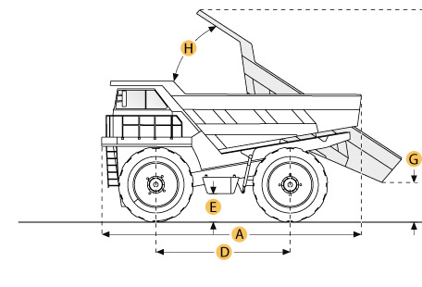

Selected Dimensions
Dimensions
A. Overall Length | 32.1 ft in | 9780 mm
B. Overall Width | 20 ft in | 6100 mm
C. Overall Height | 16.4 ft in | 5000 mm
D. Wheelbase | 15 ft in | 4570 mm
E. Ground Clearance | 2.3 ft in | 700 mm
F. Dump Height | 32.7 ft in | 9970 mm
G. Dump Ground Clearance | 2.9 ft in | 872 mm

Specification
Engine
Make | Caterpillar
Model | 3508A
Gross Power | 1000 hp | 745.7 kw
Net Power | 938 hp | 699.5 kw
Displacement | 2105.3 cu in | 34.5 L
Max Torque | 3476.1 lb ft | 4713 Nm
Torque Measured @ | 1300 rpm
Operational
Fuel Capacity | 300.4 gal | 1137 L
Cooling System Fluid Capacity | 85.9 gal | 325 L
Engine Oil Capacity | 32.8 gal | 124 L
Diff and Final Drive Fluid Capacity | 86.9 gal | 329 L
Steering System Fluid Capacity | 22.2 gal | 84 L
Brake/Hoist System Fluid Capacity | 109.6 gal | 415 L
Hydraulic System Fluid Capacity | 36.5 gal | 138 L
Transmission
Type | automatic power shift
Number of Gears - Forward | 7
Number of Gears - Reverse | 1
Max Speed | 37.5 mph | 60.4 km/h
Weights
Empty Weight | 155000 lb | 70306.8 kg
Loaded Weight | 355010.4 lb | 161030 kg
Weight Distribution Front - empty | 45.4 %
Weight Distribution Rear - empty | 54.6 %
Weight Distribution Front - loaded | 33.3 %
Weight Distribution Rear - loaded | 66.7 %
Dump
Rated Payload | 200000 lb | 90718.5 kg
Load Capacity - Struck | 54.9 yd3 | 42 m3
Load Capacity - heaped | 79.1 yd3 | 60.5 m3
Raise Time | 15 sec
Dimensions
Overall Length | 32.1 ft in | 9780 mm
Overall Width | 20 ft in | 6100 mm
Overall Height | 16.4 ft in | 5000 mm
Wheelbase | 15 ft in | 4570 mm
Ground Clearance | 2.3 ft in | 700 mm
Dump Height | 32.7 ft in | 9970 mm
Dump Ground Clearance | 2.9 ft in | 872 mm

