Terex 4066C Articulated Dump Truck
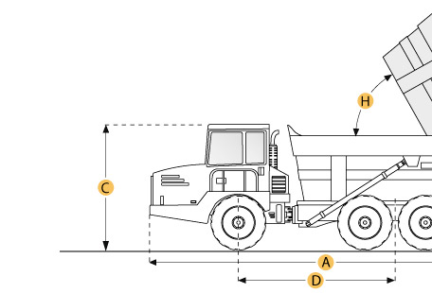

Selected Dimensions
Dimensions
A. Overall Length | 34.9 ft in | 10650 mm
B. Overall Width | 11.3 ft in | 3430 mm
C. Overall Height | 12 ft in | 3660 mm
D. Wheelbase | 18.3 ft in | 5585 mm
E. Ground Clearance | 1.9 ft in | 580 mm
F. Dump Height | 21.5 ft in | 6540 mm
G. Dump Ground Clearance | 2.4 ft in | 730 mm
Dump
H. Dump Angle | 65 degrees

Specification
Engine
Make | Detroit Diesel
Model | Series 60
Gross Power | 400 hp | 298.3 kw
Net Power | 375 hp | 279.6 kw
Power Measured @ | 2100 rpm
Displacement | 775 cu in | 12.7 L
Torque Measured @ | 1200 rpm
Max Torque | 1450 lb ft | 1965.9 Nm
Number of Cylinders | 6
Aspiration | turbocharged with air-to-air charge cooling, water-cooled
Operational
Fuel Capacity | 112 gal | 424 L
Hydraulic System Fluid Capacity | 45 gal | 170.3 L
Cooling System Fluid Capacity | 23 gal | 87.1 L
Engine Oil Capacity | 9.5 gal | 36 L
Transmission Fluid Capacity | 11 gal | 41.6 L
Operating Voltage | 24 V
Alternator Supplied Amperage | 70 amps
Tire Size | 26.5 R 25
Transmission
Type | ZF 6WG 65 Automatic with manual override
Number of Forward Gears | 6
Number of Reverse Gears | 3
Max Speed | 28 mph | 45.1 km/h
Weights
Front Axle - empty | 31345 lb | 14217.9 kg
Center Axle - empty | 16800 lb | 7620.4 kg
Rear Axle - empty | 16870 lb | 7652.1 kg
Front Axle - loaded | 41315 lb | 18740.2 kg
Center Axle - loaded | 52085 lb | 23625.4 kg
Rear Axle - loaded | 52085 lb | 23625.4 kg
Total Empty | 65015 lb | 29490.3 kg
Total Loaded | 145485 lb | 65990.9 kg
Dump
Rated Payload | 80470 lb | 36500.6 kg
Capacity - Struck | 22.2 yd3 | 17 m3
Capacity - Heaped | 28.8 yd3 | 22 m3
Dump Angle | 65 degrees
Raise Time | 16 sec
Lower Time | 12 sec
Dimensions
Overall Length | 34.9 ft in | 10650 mm
Overall Width | 11.3 ft in | 3430 mm
Overall Height | 12 ft in | 3660 mm
Wheelbase | 18.3 ft in | 5585 mm
Ground Clearance | 1.9 ft in | 580 mm
Dump Height | 21.5 ft in | 6540 mm
Dump Ground Clearance | 2.4 ft in | 730 mm

