LINK-BELT d300 Articulated Dump Truck
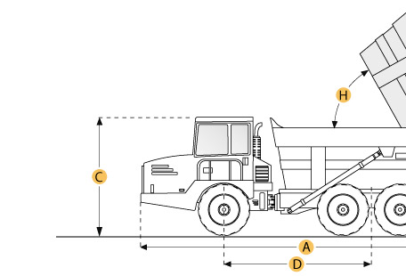

Selected Dimensions
Dimensions
A. Overall Length | 31.5 ft in | 9608 mm
B. Overall Width | 9.2 ft in | 2795 mm
C. Overall Height | 11.5 ft in | 3517 mm
D. Wheelbase | 17 ft in | 5183 mm
E. Ground Clearance | 1.7 ft in | 526 mm
F. Dump Height | 21 ft in | 6394 mm
G. Dump Ground Clearance | 2.7 ft in | 830 mm
Dump
H. Dump Angle | 67 degrees

Specification
Engine
Make | Cummins
Model | MTA 11-C
Gross Power | 300 hp | 223.7 kw
Net Power | 286 hp | 213.3 kw
Power Measured @ | 2100 rpm
Displacement | 659 cu in | 10.8 L
Torque Measured @ | 1300 rpm
Max Torque | 1015 lb ft | 1376.2 Nm
Number of Cylinders | 6
Aspiration | Turbocharged
Operational
Fuel Capacity | 85.9 gal | 325 L
Hydraulic System Fluid Capacity | 79.3 gal | 300 L
Cooling System Fluid Capacity | 3.4 gal | 13 L
Engine Oil Capacity | 8.7 gal | 33 L
Transmission Fluid Capacity | 10 gal | 38 L
Operating Voltage | 24 V
Alternator Supplied Amperage | 70 amps
Tire Size | 23.5 R25
Transmission
Type | Power Shift
Number of Forward Gears | 6
Number of Reverse Gears | 3
Max Speed | 27.7 mph | 44.6 km/h
Weights
Front Axle - empty | 21583 lb | 9789.9 kg
Rear Axle - empty | 21606 lb | 9800.3 kg
Total Empty | 43189 lb | 19590.2 kg
Total Loaded | 102713 lb | 46589.8 kg
Dump
Rated Payload | 59525 lb | 27000.1 kg
Capacity - Struck | 17 yd3 | 13 m3
Capacity - Heaped | 20.9 yd3 | 16 m3
Dump Angle | 67 degrees
Raise Time | 14 sec
Lower Time | 16 sec
Dimensions
Overall Length | 31.5 ft in | 9608 mm
Overall Width | 9.2 ft in | 2795 mm
Overall Height | 11.5 ft in | 3517 mm
Wheelbase | 17 ft in | 5183 mm
Ground Clearance | 1.7 ft in | 526 mm
Dump Height | 21 ft in | 6394 mm
Dump Ground Clearance | 2.7 ft in | 830 mm

