Caterpillar D40D Articulated Dump Truck
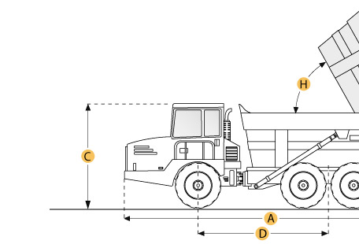

Selected Dimensions
Dimensions
A. Overall Length | 32 ft in | 9760 mm
B. Overall Width | 11.4 ft in | 3460 mm
C. Overall Height | 11.7 ft in | 3560 mm
D. Wheelbase | 15.9 ft in | 4850 mm
F. Dump Height | 18 ft in | 5490 mm

Specification
Engine
Make | Caterpillar
Model | 3406
Gross Power | 385 hp | 287.1 kw
Displacement | 890.9 cu in | 14.6 L
Operational
Fuel Capacity | 118.9 gal | 450 L
Tire Size | front 29.5x25 Radials, rear 33.25x29 Radials
Transmission
Number of Forward Gears | 4
Max Speed | 34.2 mph | 55 km/h
Weights
Front Axle - empty | 38309.7 lb | 17377 kg
Rear Axle - empty | 23479.2 lb | 10650 kg
Front Axle - loaded | 55291.9 lb | 25080 kg
Rear Axle - loaded | 86482.9 lb | 39228 kg
Total Empty | 61789 lb | 28027 kg
Total Loaded | 141774.9 lb | 64308 kg
Dump
Rated Payload | 79985.9 lb | 36281 kg
Capacity - Struck | 22.1 yd3 | 16.9 m3
Capacity - Heaped | 29.3 yd3 | 22.4 m3
Dimensions
Overall Length | 32 ft in | 9760 mm
Overall Width | 11.4 ft in | 3460 mm
Overall Height | 11.7 ft in | 3560 mm
Wheelbase | 15.9 ft in | 4850 mm
Dump Height | 18 ft in | 5490 mm

