Caterpillar D350D Articulated Dump Truck
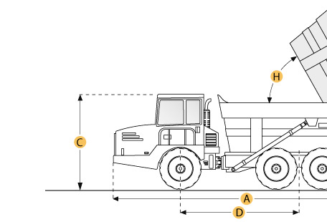

Selected Dimensions
Dimensions
A. Overall Length | 32.6 ft in | 9950 mm
B. Overall Width | 9.8 ft in | 3000 mm
C. Overall Height | 10.9 ft in | 3330 mm
D. Wheelbase | 19.3 ft in | 5890 mm
F. Dump Height | 21.4 ft in | 6520 mm

Specification
Engine
Make | Caterpillar
Model | 3306
Gross Power | 285.6 hp | 213 kw
Displacement | 640.7 cu in | 10.5 L
Operational
Fuel Capacity | 118.9 gal | 450 L
Tire Size | 26.5x25 Radials
Transmission
Number of Forward Gears | 5
Max Speed | 29.8 mph | 48 km/h
Weights
Front Axle - empty | 30364.3 lb | 13773 kg
Center Axle - empty | 11929.2 lb | 5411 kg
Rear Axle - empty | 11929.2 lb | 5411 kg
Front Axle - loaded | 42227.3 lb | 19154 kg
Center Axle - loaded | 40474.7 lb | 18359 kg
Rear Axle - loaded | 40474.7 lb | 18359 kg
Total Empty | 54222.7 lb | 24595 kg
Total Loaded | 124199.6 lb | 56336 kg
Dump
Rated Payload | 69976.9 lb | 31741 kg
Capacity - Struck | 20.9 yd3 | 16 m3
Capacity - Heaped | 26.8 yd3 | 20.5 m3
Dimensions
Overall Length | 32.6 ft in | 9950 mm
Overall Width | 9.8 ft in | 3000 mm
Overall Height | 10.9 ft in | 3330 mm
Wheelbase | 19.3 ft in | 5890 mm
Dump Height | 21.4 ft in | 6520 mm

