12-422 Caterpillar PR660 4х4 колёсный тягач, рабочий вес 27.5 тн, c одноосным полуприцепом задней выгрузки Athey для горных пород гп 54 тн ёмк. 42.5 м3, полный веc 108 тн, Cat D346/D346T 450/500 лс, 64 км/час, США 1960-е г.
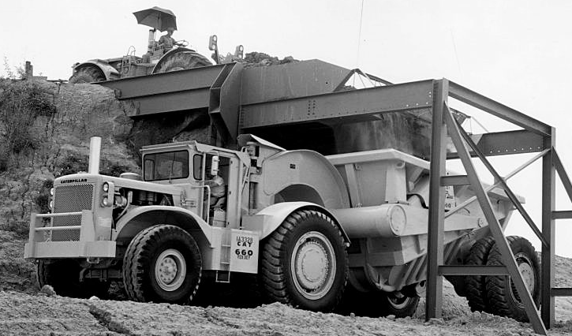

The Cat PR660 Rear Dump is comprised of a Cat 660 Four-Wheel Tractor towing a PR660 Rear Dump Trailer. Featuring a 500HP diesel engine and Power Shift transmission, the 660 has 9 forward and 3 reverse gears. Equipped with dual tractor and trailer tires with rock busters, the PR660 is able to easily maneuver through uneven loading conditions. Measuring approximately 45’ 5” long, 16’ 6” wide, and 13’ 10” tall, the empty PR660 weighs in at 103,200 lbs. With a heaped capacity of 56 yd.³, the machine has a payload capacity of 60 tons.

Type | Four Wheel-Tractor/Trailer
Horsepower | 500HP @ 1900RPM
Transmission | Power Shift – 9 forward & 3 reverse gears
Length | 45' 5"
Width | 16' 6"
Height | 13' 10"
Max Dump Height | 24' 3"
Operating Weight | 103,200 lbs.
Payload Capacity | 120,000 lbs.
Capacity (Struck) | 40 yd.³
Capacity (Heaped) | 56 yd.³

Somewhat overshadowed by it’s legendary twin engined sibling, the Cat 666, it may surprise readers to know that there are far more Caterpillar 660’s still in operation and earning their keep some forty years after the last one came off the production line!
Caterpillar introduced their 600 series in 1959 with the 14 cubic yard Cat 619B.
This was followed by the 21 cubic yard 631A in 1960 and then by a whole range of machines in 1962, with capacities right up to 54 cubic yards.
This was at a time when the motor scraper reigned supreme and was the chosen type of earthmoving machine for most jobs other than solid rock.
Caterpillar introduced three really big three-axle scrapers that year, the 650, 660 and 666.
All shared the same tractor unit but had differently configured bowls and the 666 was of course, tandem powered.
In order to provide maximum cost and time savings, all three were designed to be tandem pushed in the cut to cut down loading and loiter time.
The Peterson Tractor Co, a Cat dealer in California developed a special version of the (then) current Cat D9G track type tractor to push these monsters known as the tandem D9G – two D9G’s joined together by a frame, ball joint and operated by one man. The idea proved to be so successful, the patent rights to this design were purchased from Peterson by Caterpillar and the type was put into series production as the DD9G, and later on, the DD9H. It was only discontinued when Cat introduced their D10 in 1977.
Three-axle scrapers have a couple of advantages over the two-axle, overhung type. First of all is speed, as provided the haul road is smooth and well maintained, top speed can safely be attained and maintained. Secondly is ride comfort. A three-axle scraper has considerably better riding characteristics as compared to a two-axle scraper, even a cushion hitch equipped example. Where the three-axle scraper has problems are with adverse grades and maneuverability – it takes quite a bit of real estate to turn one of these things around and hilly terrain does present some challenges.
Our chosen subject, the 660, was designed for high speed, bulk earthmoving over terrain with few grades, and had a 40 cubic yard struck, 54 cubic yard heaped capacity bowl.
It was powered by a single 450 horsepower Caterpillar D346 V8 diesel engine and was known as the 90F series.
Caterpillar built 109 of these machines and it was only in production for two years before it was replaced by the 77F series which featured 50 more horsepower and a wider variety of tyre options.
Both the 90F and 77F series 660 had a nine-speed Cat powershift transmission which allowed a top speed of around 40 miles per hour – not bad for a machine weighing 120 tons loaded!
The 660 remained pretty much unchanged until 1969 when Caterpillar brought out a revised version, the 660B (58K series). Featuring a lot of improvements over the previous versions, these included an uprated engine, the Cat D346TA which was now putting out 550 flywheel horsepower, and the recently developed Caterpillar 8-speed semi-automatic powershift transmission. Another major revision was to the bowl which had the lift cylinders removed from their previous position either side of the gooseneck, outboard almost to the end of the draft tube.
This last change was apparently to help avoid the bowl from going out of ‘square’ when serious horsepower was applied to the pushblock and the cutting edge struck something solid. These changes resulted in a slight weight loss for the machine, down to 117 tons loaded.
With it’s slimmed-down look, new transmission and fifty more horses under the hood, the 660B could make almost 45 miles per hour.
Regrettably for Caterpillar, the world was headed for an international slump in the sales of large earthmovers and sales for large scrapers dried up.
Caterpillar made the decision to remove all of their large 3-axle scrapers from production around 1975 and has not seen fit to reintroduced them, leaving their model 657 as the only large motor scraper currently in production.
However, owing to its simplicity, ruggedness and sheer bulk dirt shifting ability, many 660’s and 660B’s remain in service, especially in California where they can be seen running in fleets, an awe-inspiring sight.
As the Cat D346 engine does not meet California states ridiculously low emission requirements, almost all of these machines have been repowered, the favoured engine being a Detroit Diesel 60 series!
Optional Equipment
The 660 was available with a range of optional items to suit different operating conditions.
These included a cab with heater, fast fuelling system, a choice of gasoline starting engine or electric starter for the engine, a Caterpillar Tractionaide, a hydraulically operated device for weight transfer to the drive wheels and different tyre options.
Along with the model 660 scraper, additional equipment was available from preferred supplier Athey in the form of the 130 ton PH660 Coal Bottom Dump, 100 ton PW660 Earth Bottom Dump and the PR660 Rock Rear Dump.
Although 660’s and 660B’s look very similar, there is one very prominent distinguishing spotting feature – on the early 660’s, the bowl lift rams are grouped together on the gooseneck. On a 660B, the bowl lift rams are mounted outboard near the ends of the draft tube.

