Liebherr T262 Rock Truck
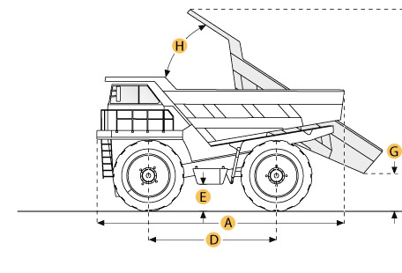
Selected Dimensions
Dimensions
A. Overall Length | 43.6 ft in | 13300 mm
B. Overall Width | 24.3 ft in | 7400 mm
C. Overall Height | 22 ft in | 6700 mm
D. Wheelbase | 20 ft in | 6100 mm
F. Dump Height | 19.4 ft in | 5900 mm
Dump
H. Dump Angle | 50 degrees

Specification
Engine
Model | DDC/MTU 12V4000
Gross Power | 2500 hp | 1864 kw
Operational
Fuel Capacity | 929.9 gal | 3520 L
Steering System Fluid Capacity | 125 gal | 473 L
Brake/Hoist System Fluid Capacity | 350 gal | 1325 L
Operating Voltage | 24 V
Alternator Supplied Amperage | 75 amps
Tire Size | 40R57
Transmission
Max Speed | 32 mph | 51.5 km/h
Weights
Empty Weight | 345993.5 lb | 156940 kg
Loaded Weight | 860001.3 lb | 390090 kg
Dump
Load Capacity - Struck | 109.9 yd3 | 84 m3
Load Capacity - heaped | 155.6 yd3 | 119 m3
Dump Angle | 50 degrees
Raise Time | 21 sec
Lower Time | 14 sec
Dimensions
Overall Length | 43.6 ft in | 13300 mm
Overall Width | 24.3 ft in | 7400 mm
Overall Height | 22 ft in | 6700 mm
Wheelbase | 20 ft in | 6100 mm
Dump Height | 19.4 ft in | 5900 mm

