12-410 International HX615 Standard Cab 6х4 автобетоносмеситель McNeilus® Standard задней выгрузки ёмк. 8 м3, полный вес 31 тн, Navistar N13 410-415 лс, США 2017 г.
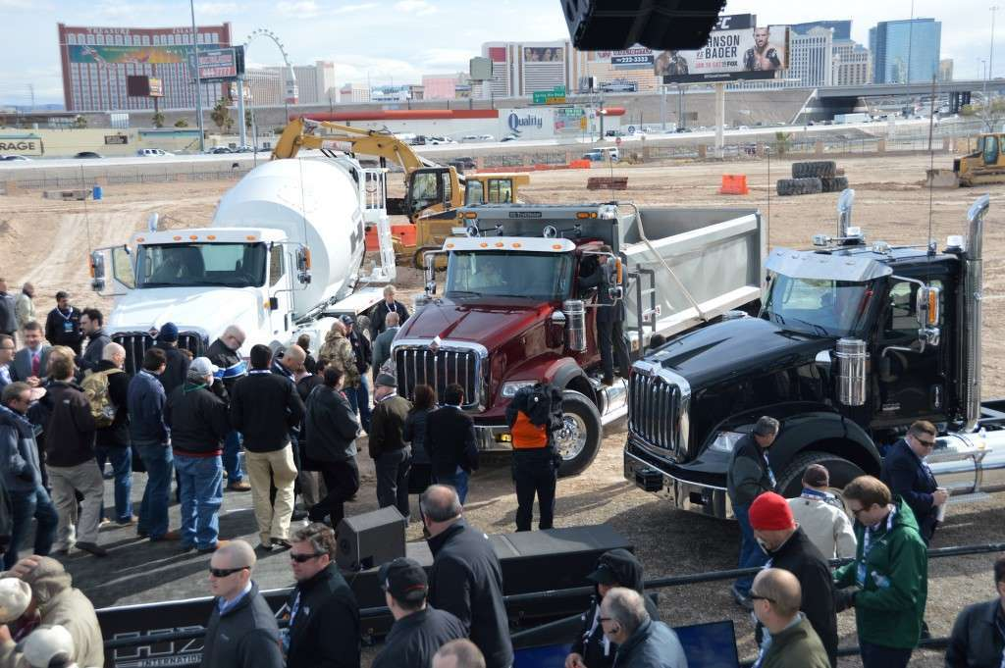
On Monday, one day prior to the opening of the World of Concrete show in Las Vegas, International debuted it’s new Class 8, HX series of vocational trucks—the first completely new line the company has offered since 2010.
The new HX Series trucks feature a huck bolted frame and cross members and a 12.5-inch single frame rail to stand up to the twisting and racking forces encountered on uneven ground. Rated at 3.5 million rbm, the rails weigh 13 percent less than a 10-inch rail, which gives you more weight for payload.
Three models of International’s new HX line debuted in Las Vegas. A fourth will be shown in April at the Truck World show in Toronto.
The cab is constructed of aluminum for rustproof longevity and sits on an air-ride suspension system and 52 inch springs to help even out the bumps and ruts found on most construction sites. The wheel cuts crank to 40 degrees for increased maneuverability in tight spaces. A three-piece Metton hood keeps the weight down and is less prone to damage and cracking than fiberglass.
On the inside, the cab features all the bells and whistles drivers come to expect in a premium truck including: standard power windows and locks, air conditioning, tilt and telescoping steering wheel, LED lighting, and an angled right-hand console for better visibility to gauges. The doors swing on long-lasting stainless steel piano hinges.
If you have occasion to do recovery work, the HX series sports a tow pin with a 150,000-pound rating, the industry’s highest, according to International.
The company is offering four models of HX series trucks, both set-forward and set-back front axle models in either short or long hood. In Las Vegas the company showed three models including:
- The HX515, a 115-inch BBC set-forward axle for concrete mixer, construction dump, refuse/roll-off and crane applications.
- The HX615, a 115-inch BBC set-back axle for construction dump, concrete mixer, platform stake/crane and refuse/roll-off tractors.
- The HX620, a 120-inch BBC set-back axle with primary vocations including heavy haul tractor, construction dump and platform stake/crane.
A fourth model, the HX520, will be unveiled at Truck World in Toronto in April. It has a 120-inch BBC set-forward axle for heavy haul, construction dump and platform stake/crane applications.
The HX515 and the HX615 models will come with Navistar N13 engines.
The HX520 and HX620 models offer the Cummins® ISX15 engine.
The HX series will replace International’s PayStar series of trucks.

NEW 2018 International HX615 with 10.5 yard Beck Concrete Mixer, N13, 410HP, 1,450 lb-ft Torque, Allison 4500RDS Automatic Transmission, 22,000 lbs. Front Axle, 46,000 lbs. Rear Axle, Walking Beam Suspension, 6-Channel ABS Brakes w/ Traction Control, 68,000 lbs. GVWR, Power Windows, Locks, and Mirrors, Air Suspension Driver's Seat,

Make: | INTERNATIONAL
Model: | HX615
Class: | CLASS 8 (GVW 33001 - 150000)
Category: | Mixer Truck
Cab Type: | STANDARD CAB
Location: | AUSTIN, TX
Max Horse Power: | 410-450
Max Torque: | 1450-1700
Fuel Type: | Diesel
Axles: | 6x4
Rear Axles: | Tandem
Suspension: | Beam
Wheelbase: | 230
Front Axle: | 22,000
Rear Axle: | 46,000
Number of Rear Axles: | 2
Brake Type: | Air
VIN: | 3HTDSSNT9JN493263
Drivetrain: | 6X4
Engine Manufacture: | International
Engine Size: | 12.4L cc
Weight: | Over 55001
Transmission Make: | Allison
Transmission Speed: | 6
Transmission Type: | Automatic
Color: | White
Fuel Tank Size: | 60
Upfit Body Type: | Concrete Mixer Trucks
Upfit Make: | BECK
Upfit Model: | Beck Standard Concrete Mixer Truck
Options:
Air Conditioning, Cruise Control, AM/FM Radio, Air Seat, Aluminum Wheels, Power Steering, Power Mirrors, Power Locks, Power Driver Seat, Trip Odometer, Tilt Steering Wheel, Anti-Lock Braking System, Air Brakes, Dual Breathers, Heated Mirrors, Heavy Duty Transmission, Locking Differential, Steel Wheels, Heavy Specs, EPA Compliant, Bluetooth

Specifications
MODEL YEAR NEW STANDARD ADDITIONS
- McNeilus FLEX Controls cable version (EP version optional)
- Improved fender design to increase durability and corrosion resistance, lightweight aluminum option available
- Simplified and enclosed chute lock design to protect components from debris
- Increased fin spiral rebar thickness to lengthen fin life
- Access hole added to front pedestal for easy maintenance
- Improved M80 Series Drum hydraulic hose routing
STANDARD BODY
Drum Capacity | 11 cu yd.
Discharge Opening | 42 in.
Drum Transmission | PMP PMB 7.1
Head Thickness | 1/4 in.
Skin Thickness | 3/16 in.
Fin Thickness | 3/16 in.
Surge Fins | Bolted
Hatch | One, bolted
STANDARD MAIN CHUTE
Length | 5 ft.
Chute Material | Steel
STANDARD FOLD-OVER CHUTE AND EXTENSIONS
Lift | Hydraulic-driven
Lock | Air lock
Length | Transitional 30in.
Extension 1 | 4 ft.
Extension 2 | 4 ft.
STANDARD WATER SYSTEM
Tank | Steel, 125 gallon
Water Valves | Standard ball valves
STANDARD LIGHTING
LED lights
3-bar light located on charge hopper
STANDARD HYDRAULICS
Pump | Eaton 54 Series
Motor | Eaton 54 Series
Reservoir | Nylon
Reservoir Mounting | Inside of pedestal
STANDARD CONTROLS
Drum Control Type | FLEX Controls Cable
Cab Configuration | Cable controls
STANDARD FENDERS
Skin Material | Steel
Mud Flaps | White plastic
PAINT
- Drum and components steel shot blasted prior to priming with high solids epoxy primer
- Standard Finish: One color (white), Sikken’s Autocoat BT LV650 Topcoat, a high performance, high solids polyurethane
POPULAR OPTIONS
- FLEX Controls
- Washout system
- Aluminum water tank
- Back up camera
- Lightweight chutes
- Flip-up hopper
- SAT hopper
- Head impeller (lined/unlined)
- Split PTO cover
- 46 in. paver discharge opening
- ZF drum drive
- Enviroguard washout system
- Chute wash recovery system
- Rock buster or chute shutter
- Tow recovery hook

