Delmag Foundation Rig RH 18/200
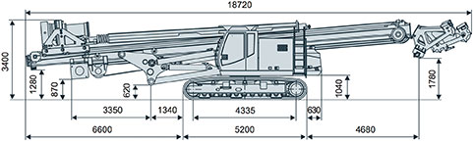

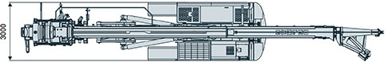

Specifications:
Total height | mm | 19900
Drilling distance max. (center) | mm | 4000
Ground clearence-mast foot | mm | 1570
Inclination forward/backward | deg | 4/14
Inclination left/right | deg | 9.5/9.5
Crowd winch force up/down | kN | 260/150
Crowd winch speed rapid/working | m/min | 25/7
Stroke | mm | 12400

Base carrier: ST 25 E
Engine power Scania DC9 | kW | 257
Track shoes | mm | 700
Back pivoting radius | mm | 3230

Transport weight:
Transport weight with rotary head and Kelly bar K368/3-18 | kg | 60000

Transport dimensions:
Length | mm | 18720
Width | mm | 3000
Height | mm | 3400

