CATERPILLAR 825b Compactor
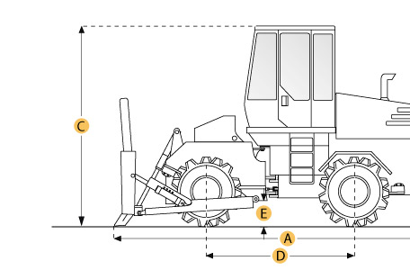

Selected Dimensions
Dimensions
A. Length With Blade on Ground | 23.3 ft in | 7100 mm
B. Width Over Wheels | 12 ft in | 3650 mm
C. Height to Top of Cab | 12.1 ft in | 3680 mm
D. Wheelbase | 11.6 ft in | 3550 mm
E. Ground Clearance | 1.5 ft in | 470 mm

Specification
Engine
Model | D343
Gross Power | 300 hp | 223.7 kw
Displacement | 890.9 cu in | 14.6 L
Operational
Operating Weight | 67814.2 lb | 30760 kg
Fuel Capacity | 229.8 gal | 870 L
Transmission
Max Speed | 8 mph | 12.9 km/h
Wheels
Front Wheels Drum Width | 44.5 in | 1130 mm
Front Wheels Drum Diameter | 66.1 in | 1680 mm
Blade
Height | 40.6 in | 1030 mm
Width | 13.6 ft in | 4150 mm
Dimensions
Length with Blade on Ground | 23.3 ft in | 7100 mm
Width Over Wheels | 12 ft in | 3650 mm
Height to Top of Cab | 12.1 ft in | 3680 mm
Wheelbase | 11.6 ft in | 3550 mm
Ground Clearance | 1.5 ft in | 470 mm

