13-257 Caterpillar D6 серии 9U гусеничный бульдозер с прицепным гидравлическим скрепером LaPlant-Choate TW-10 Carrimor емкостью 7.6 м3 с шапкой, Cat D333 93 лс, 11 км/час, США 1950-е г.
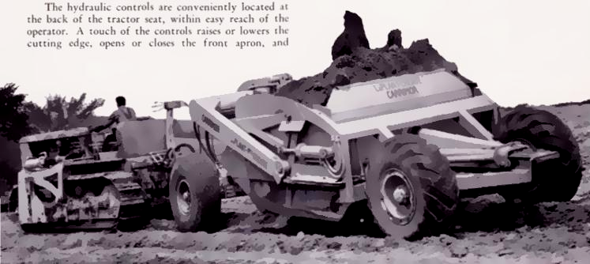

13-257 Caterpillar D6 9U Series crawler dozer with LaPlant-Choate TW-10 Carrimor towed hydraulic scraper, capacity 10 cubic yards heaped, Cat D333 93 HP, 6.8 mph, USA 1950-s.

Многие владельцы тракторов "Caterpillar” хотели использовать скрепер CW-10 для своих гусеничных машин. По этой причине для CW-10 был разработан передний колесный узел, а прицепной агрегат назвали скрепер TW-10 "Carrimor". Это дало подрядчикам много преимуществ гидравлической землеройной машины с 10-ярдовым ковшом, наряду с длительным сроком службы и качеством CW-10.
Гидравлические органы управления удобно расположены в задней части сиденья трактора, в пределах легкой досягаемости оператором. Прикосновение к элементам управления поднимает или опускает режущую кромку, открывает или закрывает передний фартук и приводит в действие эжектор или задний затвор.
10-ярдовые грузы быстро и легко транспортируются к насыпи и равномерно распределяются по любому желаемому месту толщиной от 0 до 15 дюймов. Очень большие 16-слойные шины, все 16:00 x 20, обеспечивают максимальную флотацию, а правильная конструкция протектора шины исключает большую часть заглубления в мягких грунтах и позволяет гораздо легче поворачивать в любом движении. Конические роликовые подшипники в колесах придают скребку легкую способность к качению.

Many owners of "Caterpillar” tractors will want the CW-10 Scraper for use with their track-
type machines. For this reason, a front wheel assembly has been made available for the CW-10. and the
tractor-drawn outfit is called the TW-10 "Carrimor" Scraper. This will give counties, contractors, and
others the many advantages of hydraulic earthmoving with a 10-yard machine, along with the long life,
case of operation, and quality built into the CW-10
The hydraulic controls are conveniently located at the back of the tractor seat, within easy reach of the
operator. A touch of the controls raises or lowers the cutting edge, opens or closes the front apron, and operates the positive ejector or rear gate. The ejector, of course, also returns positively in the same manner.
Heaping ten yard loads are quickly and easily transported to the fill and uniformly spread to any desired
depth from 0 to 15 inches. Extra large 16-ply tires, all 16:00 x 20, provide maximum flotation, and proper tire tread design eliminates much of the suction in soft soils and permits much easier turning in any going. Tapered roller bearings in the wheels give the scraper effortless rolling ability.

contractormag.co.nz
LaPlant-Chote began offering scrapers as early as 1935 and was a pioneer in the field of hydraulic controls. It adopted the trade name of “Carrimor” for its towed scrapers, the most popular models of which included the C-94, C-104, C-108 and the 8.5 cubic yard TW-10 that was built specifically for Caterpillar’s DW-10 tractor. These modifications were also applied across the entire range of Caterpillar’s towed scrapers as well.
The Towed Scrapers of LaPlant-Choate
LaPlant-Choate called their towed scrapers ‘Carrimors’, a direct dig at LeTourneau’s ‘Carryalls.’
One of the features of LaPlant-Choate’s scrapers was their curved bowl floor and cutting edge which loaded very aggressively compared to a lot of their competitors. This was also a bit of a handicap when it came to finishing work as a special cutting edge had to be fitted to perform the task. A good mix of sizes was available from 2.5 through to 33 cubic yards capacity.
All of the towed scrapers under 10 cubic yards were hydraulically controlled while those of larger capacity were cable controlled. When Allis-Chalmers took over the company, not all of the models were retained in the product line-up, most noticeably the small single axle Carrimors. The large 33 cubic yard C104 did not make it either.
Established in 1911 in Cedar Rapids, Iowa, LaPlant-Choate originally got its start in the construction industry by building house moving equipment. This expanded to the manufacture of rudimentary bulldozer blades by 1927 and then on to towed scrapers, compaction equipment and rippers.
By 1939 LaPlant-Choate was a thriving concern and a major supplier of equipment to Caterpillar, both cable and hydraulically operated. LaPlant-Choate’s hydraulic pumps were one of the most simple and therefore reliable of all the early hydraulic units available and employed gears rather than vanes to pump the oil under pressure through the system. Critically, they were equipped with a filter in the return line to the tank.
The company’s gear type hydraulic pumps wore at a much slower rate than the vane type pumps favored by its competitors that were susceptible to the rather indifferent quality hydraulic oil of the time.
Although LaPlant-Choate never built a cable control unit (PCU), it did manufacture a large range of cable operated equipment, relying on other manufacturers, such as GarWood, Isaacson and LeTourneau to furnish a suitable PCU.
Rivalry exisited between LaPlant-Choate and LeTourneau as both companies had preferred supplier agreements with Caterpillar who sold both of their products through Cat’s extensive worldwide dealer network.
LaPlant-Choate, just like LeTourneau, was a victim of Caterpillar’s decision to develop and manufacture its own attachments. In 1944 Cat pulled the plug on both companies, collapsing LaPlant’s distributor network.
Setting up a new sales, parts and service network from scratch takes time and a considerable amount of capital, something which severely stretched the company financially.
However, this setback did not deter the company from developing and marketing it’s first motor scraper, the 18 cubic yard Model TS-300 in 1946 followed in 1950 by the 13 cubic yard TS-200.
It should be noted here that LaPlant-Choate coined the trademark “Moto-Scraper”, later expanding it to “Motor Scraper” which has now become a generic term for all machines of this type!
Both the TS-300 and TS-200 were well accepted by contractors but sufficient operating capital was still a problem for the company. LaPlant-Choate also tried building a rubber tyred push tractor, the Model TD-300, but only manufactured a few before the type was withdrawn.
Finally, in September 1952, LaPlant-Choate ceased to exist when Allis-Chalmers bought the entire company, its manufacturing plant & tooling, patent rights, trademarks and unsold equipment. Allis-Chalmers had been investigating scraper manufacturers that could round out its own equipment line and LaPlant-Choate filled the bill nicely. From then on all former LaPlant-Choate products were painted Persian Orange and branded as Allis-Chalmers.

http://archives.hcea.net
Historical Note:
The LaPlant-Choate Manufacturing Company was founded in 1911 by E. W. LaPlant and Roy Choate to produce stump pullers and house moving machinery. Mr. LaPlant began developing house moving equipment for his own business in Marshalltown, Iowa, and relocated to Cedar Rapids, Iowa, following work. The firm remained in Cedar Rapids for the rest of its existence.
It entered the crawler tractor attachment and allied equipment market in 1923 and was one of the first producers of the dozer and of the hydraulic control system and equipment for crawler tractors. Its products included the CW10 scraper for the Caterpillar DW10 tractor, the first scraper designed specifically for use with a Cat prime mover.
The firm was acquired by Allis-Chalmers (Collection 54) in 1952, and A-C retained LaPlant-Choate’s model nomenclature.

