CATERPILLAR 16m Motor Grader
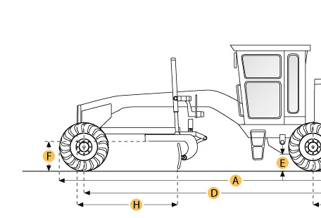
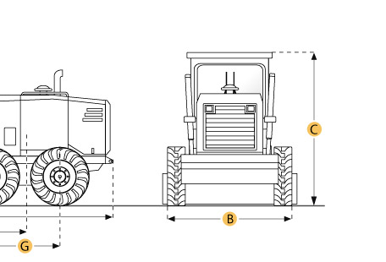

Selected Dimensions
Dimensions
A. Overall Length | 32.7 ft in | 9963 mm
B. Width Over Tires | 10.2 ft in | 3095 mm
C. Height to Top of Cab | 12.2 ft in | 3703 mm
D. Wheelbase | 22.9 ft in | 6985 mm
E. Rear Ground Clearance | 1.3 ft in | 407 mm
F. Front Ground Clearance | 2.3 ft in | 688 mm
G. Tandem Axle Wheelbase | 6 ft in | 1841 mm
H. Blade Base | 10.1 ft in | 3069 mm

Specification
Engine
Make | Caterpillar
Model | C13 ACERT VHP
Net Power Gear 1-2 | 302 hp | 225 kw
Net Power Gear 3-4 | 312 hp | 232.7 kw
Power Measured @ | 2000 rpm
Net Power Gear 5-6 | 312 hp | 232.7 kw
Number of Cylinders | 6
Net Power Gears 7-8 | 312 hp | 232.7 kw
Max Power | 312 hp | 232.7 kw
Net Torque Gears 7-8 | 1261.2 lb ft | 1710 Nm
Displacement | 763 cu in | 12.5 L
Operational
Std Operation Weight - Front Axle | 15679 lb | 7112 kg
Std Operation Weight - Rear Axle | 41773 lb | 18948 kg
Std Operation Weight - Total | 57452 lb | 26060 kg
Max Operation Weight - Front Axle | 24073 lb | 10919 kg
Max Operation Weight - Rear Axle | 54570 lb | 24753 kg
Max Operation Weight - Total | 78643 lb | 35672 kg
Fuel Capacity | 135 gal | 511 L
Cooling System Fluid Capacity | 12.3 gal | 46.5 L
Hydrauilc System Fluid Capacity | 30.1 gal | 114 L
Rear Diff/Final Drive Fluid Capacity | 30.1 gal | 114 L
Circle Gearbox Fluid Capacity | 2.1 gal | 8 L
Tandem Case Fluid Capacity (each) | 32.1 gal | 121.5 L
Tire Size | 18.00-25 12PR (G-2)
Transmission
Type | direct drive, power shift, countershaft
Number of Gears - Forward | 8
Number of Gears - Reverse | 6
Max Speed - Forward | 33.5 mph | 53.9 km/h
Max Speed - Reverse | 26.5 mph | 42.6 km/h
Steering
Articulation L/R | 20 degrees
Turning Radius | 29.2 ft in | 8.9 m
Front Axle
Wheel Lean | 18.2 degrees
Oscillation - Total | 32 degrees
Ground Clearance | 2.3 ft in | 688 mm
Hydraulic System
Pump Type | variable piston
Pump Flow | 74 gal/min | 280 L/min
Relief Valve Pressure | 3500 psi | 24150 kPa
Moldboard
Moldboard Width | 16 ft in | 4877 mm
Moldboard Height | 31 in | 787 mm
Moldboard Thickness | 1 in | 25 mm
Max Depth of Cut | 19.2 in | 488 mm
Side Shift Left | 25.6 in | 740 mm
Side Shift Right | 43.1 in | 1094 mm
Blade Pull at Max Weight | 49156 lb | 22297 kg
Blade Down Pressure | 42957.1 lb | 19485 kg
Circle
Diameter | 71.8 in | 1822 mm
Shift Left | 25.5 in | 647 mm
Shift Right | 23.5 in | 597 mm
Max Reach Outside Tires - Left | 90 in | 2282 mm
Max Reach Outside Tires - Right | 101.9 in | 2587 mm
Max Lift Above Ground | 15.6 in | 395 mm
Blade Tip Angle - Front | 40 degrees
Blade Tip Angle - Rear | 5 degrees
Dimensions
Height to Top of Cab | 12.2 ft in | 3703 mm
Overall Length | 32.7 ft in | 9963 mm
Width Over Tires | 10.2 ft in | 3095 mm
Wheelbase | 22.9 ft in | 6985 mm
Blade Base | 10.1 ft in | 3069 mm
Tandem Axle Wheelbase | 6 ft in | 1841 mm
Rear Ground Clearance | 1.3 ft in | 407 mm
Front Ground Clearance | 2.3 ft in | 688 mm

