Caterpillar 621B Motor Scraper
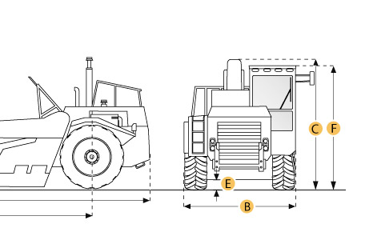
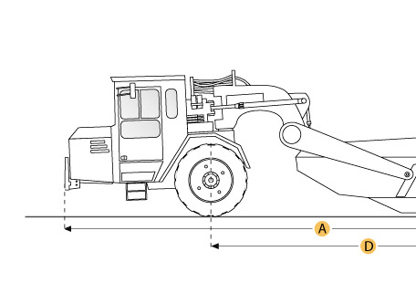

Selected Dimensions
Dimensions
A. Overall Length | 41.7 ft in | 12700 mm
B. Overall Width | 11.3 ft in | 3450 mm
C. Overall Height | 11.9 ft in | 3630 mm
D. Wheelbase | 25.3 ft in | 7720 mm

Specification
Tractor Engine
Make | Caterpillar
Model | 3406
Gross Power | hp | kw
Net Power | 330 hp | 246.1 kw
Power Measured @ | 1900 rpm
Displacement | 890.9 cu in | 14.6 L
Operational
Fuel Capacity | 135 gal | 511 L
Tire Size | 29.5-29 28PR (E-3)
Transmission
Number of Forward Gears | 8
Max Speed Forward | 29.8 mph | 48 km/h
Weights
Total Operating - empty | 66590.6 lb | 30205 kg
Front Axel - empty | 46612.3 lb | 21143 kg
Rear Axel - empty | 19977.2 lb | 9061.5 kg
Total Operating - Loaded | 114585.3 lb | 51975 kg
Front Axel - loaded | 63021.3 lb | 28586 kg
Rear Axel - loaded | 51563.9 lb | 23389 kg
Bowl
Rated Payload | 47994.6 lb | 21770 kg
Heaped Capactiy | 20 yd3 | 15.3 m3
Struck Capacity | 14 yd3 | 10.7 m3
Max Depth of Cut | 13.4 in | 340 mm
Width of Cut | 9.9 ft in | 3020 mm
Dimensions
Overall Length | 41.7 ft in | 12700 mm
Overall Width | 11.3 ft in | 3450 mm
Overall Height | 11.9 ft in | 3630 mm
Wheelbase | 25.3 ft in | 7720 mm

Caterpillar 621S Motor Scraper

Selected Dimensions
Dimensions
A. Overall Length | 42.2 ft in | 12860 mm
B. Overall Width | 11.4 ft in | 3470 mm
C. Overall Height | 12.2 ft in | 3710 mm
D. Wheelbase | 25.1 ft in | 7650 mm

Specification
Tractor Engine
Make | Caterpillar
Model | 3306
Gross Power | 280 hp | 208.8 kw
Displacement | 640.7 cu in | 10.5 L
Operational
Fuel Capacity | 144 gal | 545 L
Tire Size | 29.5-29 28PR (E-3)
Transmission
Number of Forward Gears | 8
Max Speed Forward | 27.6 mph | 44.4 km/h
Weights
Total Operating - empty | 62348.9 lb | 28281 kg
Front Axel - empty | 40527.6 lb | 18383 kg
Rear Axel - empty | 21821.4 lb | 9898 kg
Total Operating - Loaded | 110348 lb | 50053 kg
Front Axel - loaded | 56277.4 lb | 25527 kg
Rear Axel - loaded | 54070.6 lb | 24526 kg
Bowl
Rated Payload | 47999 lb | 21772 kg
Heaped Capactiy | 20 yd3 | 15.3 m3
Struck Capacity | 14 yd3 | 10.7 m3
Max Depth of Cut | 14.2 in | 361 mm
Width of Cut | 9.9 ft in | 3020 mm
Dimensions
Overall Length | 42.2 ft in | 12860 mm
Overall Width | 11.4 ft in | 3470 mm
Overall Height | 12.2 ft in | 3710 mm
Wheelbase | 25.1 ft in | 7650 mm

