Caterpillar 615 Elevating Motor Scraper
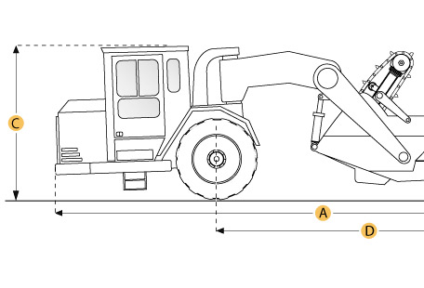

Selected Dimensions
Dimensions
A. Overall Length | 37.1 ft in | 11315 mm
B. Overall Width | 10 ft in | 3048 mm
C. Overall Height | 11.8 ft in | 3590 mm
D. Wheelbase | 22.9 ft in | 6995 mm

Specification
Tractor Engine
Make | Caterpillar
Model | 3306
Gross Power | 249.4 hp | 186 kw
Displacement | 640.7 cu in | 10.5 L
Operational
Fuel Capacity | 105.4 gal | 399 L
Tire Size | 26.5-25 26PR (E-2)
Transmission
Number of Forward Gears | 6
Max Speed Forward | 29.2 mph | 47 km/h
Weights
Total Operating - empty | 51588.2 lb | 23400 kg
Front Axel - empty | 33532.3 lb | 15210 kg
Rear Axel - empty | 18055.9 lb | 8190 kg
Total Operating - Loaded | 89992.7 lb | 40820 kg
Front Axel - loaded | 47696.1 lb | 21634.6 kg
Rear Axel - loaded | 42296.6 lb | 19185.4 kg
Bowl
Rated Payload | 38404.5 lb | 17420 kg
Heaped Capacity | 16 yd3 | 12.2 m3
Max Depth of Cut | 16.3 in | 414 mm
Width of Cut | 9.5 ft in | 2890 mm
Elevator
Number of Flights | 18
Dimensions
Overall Length | 37.1 ft in | 11315 mm
Overall Width | 10 ft in | 3048 mm
Overall Height | 11.8 ft in | 3590 mm
Wheelbase | 22.9 ft in | 6995 mm

