CATERPILLAR d9l Crawler Tractor
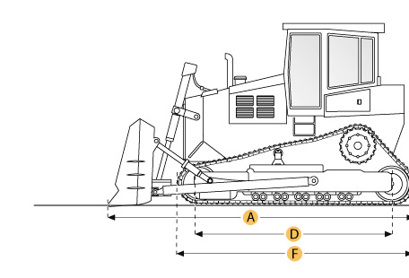

Selected Dimensions
Dimensions
A. Length w/ Blade | 23.2 ft in | 7080 mm
B. Width Over Tracks | 10.5 ft in | 3190 mm
C. Height to Top of Cab | 13.8 ft in | 4213 mm
D. Length of Track on Ground | 11.6 ft in | 3550 mm
E. Ground Clearance | 2 ft in | 610 mm
F. Length w/o Blade | 17.5 ft in | 5320 mm
Undercarriage
G. Track Gauge | 8.2 ft in | 2500 mm
H. Standard Shoe Size | 24 in | 610 mm

Specification
Engine
Make | Caterpillar
Model | 3412
Gross Power | 460 hp | 343 kw
Displacement | 1647.6 cu in | 27 L
Operational
Operating Weight | 114655.8 lb | 52007 kg
Fuel Capacity | 254.9 gal | 965 L
Transmission
Type | Powershift
Number of Forward Gears | 3
Number of Reverse Gears | 3
Max Speed - Forward | 7.6 mph | 12.2 km/h
Max Speed - Reverse | 9.3 mph | 15 km/h
Undercarriage
Ground Pressure | 17.1 psi | 118 kPa
Ground Contact Area | 6696 in2 | 4.3 m2
Standard Shoe Size | 24 in | 610 mm
Number of Track Rollers per Side | 8
Track Gauge | 8.2 ft in | 2500 mm
Standard Blade
Width | 14.9 ft in | 4540 mm
Dimensions
Length w/o Blade | 17.5 ft in | 5320 mm
Length w/ Blade | 23.2 ft in | 7080 mm
Width Over Tracks | 10.5 ft in | 3190 mm
Height to Top of Cab | 13.8 ft in | 4213 mm
Length of Track on Ground | 11.6 ft in | 3550 mm
Ground Clearance | 2 ft in | 610 mm

CATERPILLAR 631e
Bowl
Rated Payload | 75001.3 lb | 34020 kg
Heaped Capactiy | 31 yd3 | 23.7 m3
Struck Capacity | 21.1 yd3 | 16.1 m3
Max Depth of Cut | 17.2 in | 437 mm
Width of Cut | 11.5 ft in | 3490 mm
Dimensions
Overall Length | 46.9 ft in | 14280 mm
Overall Width | 12.9 ft in | 3940 mm
Overall Height | 14.1 ft in | 4290 mm
Wheelbase | 28.8 ft in | 8770 mm

