CATERPILLAR 637g Motor Scraper
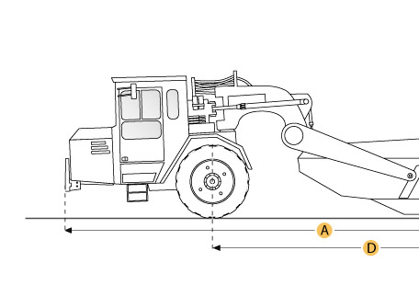

Selected Dimensions
Dimensions
A. Overall Length | 47.8 ft in | 14565 mm
B. Overall Width | 12.9 ft in | 3938 mm
C. Overall Height | 14.1 ft in | 4286 mm
D. Wheelbase | 28.8 ft in | 8769 mm
E. Tractor Ground Clearance | 2.2 ft in | 665 mm
F. Height to Top of Cab | 12.2 ft in | 3715 mm

Specification
Tractor Engine
Make | Caterpillar
Model | 3408E
Gross Power | 515 hp | 384 kw
Net Power | 490 hp | 365 kw
Displacement | 1099 cu in | 18 L
Scraper Engine
Make | Caterpillar
Model | 3306
Gross Power | 270 hp | 201 kw
Net Power | 250 hp | 186 kw
Displacement | 538 cu in | 8.8 L
Operational
Fuel Capacity | 335 gal | 1268 L
Cooling System Fluid Capacity | 52 gal | 202 L
Engine Oil Fluid Capacity | 18.9 gal | 72 L
Transmission Fluid Capacity | 45.7 gal | 176 L
Differential Fluid Capacity | 40.5 gal | 153 L
Hydraulic System Fluid Capacity | 50 gal | 190 L
Wheel Coolant Fluid Capacity - each | 39 gal | 150 L
Operating Voltage | 24 V
Alternator Supplied Amperage | 75 amps
Tire Size | 37.50-R35
Transmission
Number of Forward Gears | 8
Number of Reverse Gears | 1
Max Speed Forward | 34.1 mph | 54.9 km/h
Max Speed Reverse | 6.2 mph | 9.9 km/h
Weights
Total Operating - empty | 114745 lb | 52047 kg
Front Axel - empty | 67700 lb | 30708 kg
Rear Axel - empty | 47045 lb | 21339 kg
Total Operating - Loaded | 189745 lb | 86067 kg
Front Axel - loaded | 92975 lb | 42173 kg
Rear Axel - loaded | 96770 lb | 43894 kg
Bowl
Rated Payload | 75000 lb | 34020 kg
Heaped Capactiy | 31 yd3 | 23.7 m3
Struck Capacity | 21 yd3 | 16.1 m3
Max Depth of Cut | 17.2 in | 437 mm
Width of Cut | 11.5 ft in | 3512 mm
Dimensions
Overall Length | 47.8 ft in | 14565 mm
Overall Width | 12.9 ft in | 3938 mm
Height to Top of Cab | 12.2 ft in | 3715 mm
Overall Height | 14.1 ft in | 4286 mm
Wheelbase | 28.8 ft in | 8769 mm
Tractor Ground Clearance | 2.2 ft in | 665 mm

