Komatsu D355A-3 Crawler Tractor

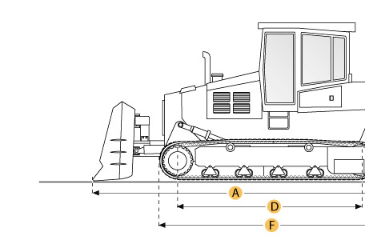
SelectedDimensions

Dimensions
A. Length w/ Blade | 30.2 ft in | 9200 mm
B. Width Over Tracks | 9.9 ft in | 3030 mm
C. Height to Top of Cab | 13.5 ft in | 4125 mm
D. Length of Track on Ground | 11 ft in | 3360 mm
E. Ground Clearance | 1.9 ft in | 575 mm
F. Length w/o Blade | 18.6 ft in | 5660 mm
Undercarriage
G. Track Gauge | 7.4 ft in | 2260 mm
H. Standard Shoe Size | 24 in | 610 mm

Specification

Engine
Make | Komatsu
Model | SA6D155-4A
Gross Power | 410 hp | 305.7 kw
Power Measured @ | 2000 rpm
Displacement | 1175.3 cu in | 19.3 L
Aspiration | turbocharged
Number of Cylinders | 6
Operational
Operating Weight | 105557.3 lb | 47880 kg
Fuel Capacity | 198.1 gal | 750 L
Cooling System Fluid Capacity | 47.6 gal | 180 L
Transmission
Type | TF
Number of Forward Gears | 4
Number of Reverse Gears | 4
Max Speed - Forward | 7.9 mph | 12.7 km/h
Max Speed - Reverse | 7.8 mph | 12.6 km/h
Undercarriage
Ground Pressure | 12.7 psi | 87.3 kPa
Standard Shoe Size | 24 in | 610 mm
Number of Shoes per Side | 39
Number of Track Rollers per Side | 7
Number of Carrier Rollers per Side | 2
Track Pitch | 10.3 in | 260.4 mm
Track Gauge | 7.4 ft in | 2260 mm
Standard Blade
Width | 14.2 ft in | 4315 mm
Height | 73.8 in | 1875 mm
Capacity | 19.9 yd3 | 15.2 m3
Cutting Depth | 27.6 in | 700 mm
Dimensions
Length w/o Blade | 18.6 ft in | 5660 mm
Length w/ Blade | 30.2 ft in | 9200 mm
Width Over Tracks | 9.9 ft in | 3030 mm
Height to Top of Cab | 13.5 ft in | 4125 mm
Length of Track on Ground | 11 ft in | 3360 mm
Ground Clearance | 1.9 ft in | 575 mm

