Caterpillar CB534 Vibratory Smooth Drum Roller
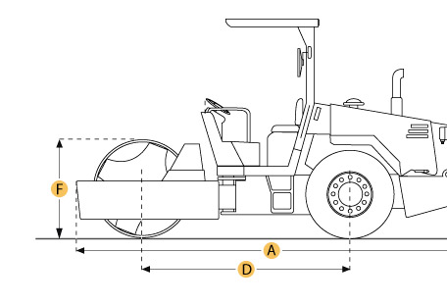

Selected Dimensions

Dimensions
A. Overall Length | 16.2 ft in | 4940 mm
B. Overall Width | 6.1 ft in | 1850 mm
C. Height to Top of Cab | 7.6 ft in | 2320 mm
D. Wheelbase | 10.3 ft in | 3140 mm
E. Ground Clearance | 15 in | 380 mm

Specification

Engine
Make | Caterpillar
Model | 3304
Gross Power | 125 hp | 93.2 kw
Displacement | 427.2 cu in | 7 L
Operational
Operating Weight | 20099.5 lb | 9117 kg
Fuel Capacity | 50.2 gal | 190 L
Engine Oil Capacity | 5 gal | 19 L
Hydraulic System Fluid Capacity | 23.8 gal | 90 L
Max Speed | 6.8 mph | 11 km/h
Drum
Drum Width | 66.9 in | 1700 mm
Drum Diameter | 51.2 in | 1300 mm
Vibration Frequency 1 | 42 Hz
Centrifugal Force - High | 26019 lb | 115.7 kN
Dimensions
Overall Length | 16.2 ft in | 4940 mm
Overall Width | 6.1 ft in | 1850 mm
Height to Top of Cab | 7.6 ft in | 2320 mm
Wheelbase | 10.3 ft in | 3140 mm
Ground Clearance | 15 in | 380 mm

