CATERPILLAR ap1000b Asphalt Paver
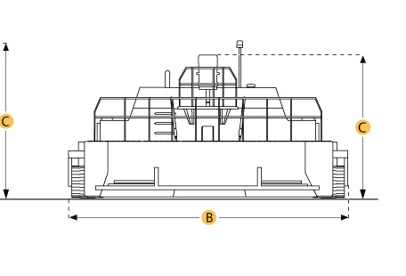
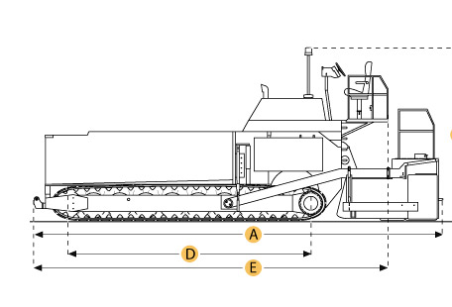

Selected Dimensions

Dimensions
A. Length w/ Screed | 22.3 ft in | 6783 mm
B. Transport Width | 10 ft in | 3048 mm
C. Transport Height | 9.1 ft in | 2769 mm
D. Wheelbase | 9.5 ft in | 2900 mm

Specification

Engine
Make | Caterpillar
Model | 3116TA
Gross Power | 174 hp | 129.8 kw
Displacement | 402.8 cu in | 6.6 L
Number of Cylinders | 6
Operational
Operating Weight w/ Screed | 35692.8 lb | 16190 kg
Fuel Capacity | 70 gal | 265 L
Hydraulic System Fluid Capacity | 49.9 gal | 189 L
Cooling System Fluid Capacity | 9.8 gal | 37 L
Hopper/Paver
Hopper Capacity | 8 yd3 | 6.1 m3
Paving Width - std | 8 ft in | 2438 mm
Paving Width - max | 30 ft in | 9147 mm
Paving Speed - max | 374 ft/min | 114 m/min
Travel Speed - max | 14.6 mph | 23.5 km/h
Auger Diameter | 16 in | 406 mm
Dimensions
Length w/ Screed | 22.3 ft in | 6783 mm
Transport Width | 10 ft in | 3048 mm
Transport Height | 9.1 ft in | 2769 mm
Tire Size | 16x22 Solid Rubber, 18x25-16 PR sand rib
Wheelbase | 9.5 ft in | 2900 mm

