CASE 885 Motor Grader
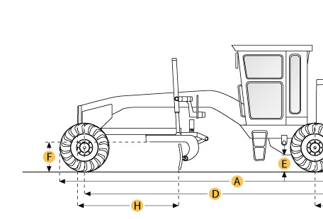
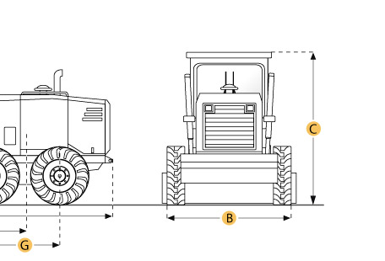

Selected Dimensions
Dimensions
A. Overall Length | 28 ft in | 8534 mm
B. Width Over Tires | 8.7 ft in | 2650 mm
C. Height to Top of Cab | 10.9 ft in | 3340 mm
D. Wheelbase | 20.4 ft in | 6219 mm
E. Rear Ground Clearance | 1.3 ft in | 380 mm
F. Front Ground Clearance | 2 ft in | 622 mm
G. Tandem Axle Wheelbase | 5.3 ft in | 1602 mm
H. Blade Base | 8.4 ft in | 2562 mm

Specification
Engine
Make | Cummins
Model | QSB 6.7, Tier III certified electronic control
Power Measured @ | 2200 rpm
Torque Measured @ | 1500 rpm
Net Power Gears 7-8 | 205 hp | 152.9 kw
Number of Cylinders | 6
Max Power | 205 hp | 152.9 kw
Net Torque Gears 7-8 | 650 lb ft | 881 Nm
Displacement | 411 cu in | 6.7 L
Aspiration | Turbocharged and Aftercooled
Operational
Std Operation Weight - Front Axle | 11227 lb | 5103 kg
Std Operation Weight - Rear Axle | 26723 lb | 12147 kg
Std Operation Weight - Total | 37950 lb | 17250 kg
Fuel Capacity | 90 gal | 340.7 L
Oil System Fluid Capacity | 4.7 gal | 17.8 L
Cooling System Fluid Capacity | 10.5 gal | 40 L
Hydrauilc System Fluid Capacity | 50.2 gal | 190 L
Transmission Fluid Capacity | 5 gal | 23 L
Rear Diff/Final Drive Fluid Capacity | 3.2 gal | 12 L
Circle Gearbox Fluid Capacity | 0.74 gal | 2.8 L
Tandem Case Fluid Capacity (each) | 6 gal | 22.7 L
Tire Size | 14.0 x 24 12PR TL G2 Firestone
Operating Voltage | 24 V
Alternator Supplied Amperage | 80 amps
Transmission
Type | Power Shift
Number of Gears - Forward | 8
Number of Gears - Reverse | 4
Max Speed - Forward | 26.7 mph | 43 km/h
Max Speed - Reverse | 19 mph | 30.6 km/h
Steering
Articulation L/R | 25 degrees
Turning Radius | 23914 ft in | 7289 m
Front Axle
Wheel Lean | 17.5 degrees
Oscillation - Total | 38 degrees
Ground Clearance | 2 ft in | 622 mm
Hydraulic System
Pump Type | Piston
Pump Flow | 37.9 gal/min | 143.5 L/min
Relief Valve Pressure | 6092 psi | 42002.8 kPa
Moldboard
Moldboard Width | 14 ft in | 4267 mm
Moldboard Height | 23.6 in | 600 mm
Moldboard Thickness | 0.88 in | 22.2 mm
Max Depth of Cut | 28 in | 711 mm
Side Shift Left | 21 in | 533 mm
Side Shift Right | 27 in | 686 mm
Circle
Diameter | 69 in | 1752 mm
Rotation | 360 degrees
Max Lift Above Ground | 17.4 in | 442.5 mm
Dimensions
Height to Top of Cab | 10.9 ft in | 3340 mm
Overall Length | 28 ft in | 8534 mm
Width Over Tires | 8.7 ft in | 2650 mm
Wheelbase | 20.4 ft in | 6219 mm
Blade Base | 8.4 ft in | 2562 mm
Tandem Axle Wheelbase | 5.3 ft in | 1602 mm
Rear Ground Clearance | 1.3 ft in | 380 mm
Front Ground Clearance | 2 ft in | 622 mm

