New Holland RG200.B Motor Grader
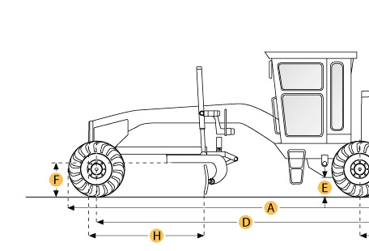
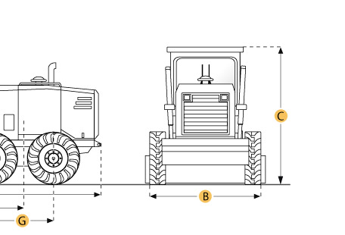

Selected Dimensions
Dimensions
A. Overall Length | 28.1 ft in | 8555 mm
B. Width Over Tires | 8.4 ft in | 2560 mm
C. Height to Top of Cab | 10.3 ft in | 3140 mm
D. Wheelbase | 20.4 ft in | 6219 mm
E. Rear Ground Clearance | 1.2 ft in | 378 mm
F. Front Ground Clearance | 2 ft in | 610 mm
G. Tandem Axle Wheelbase | 5.3 ft in | 1601 mm
H. Blade Base | 8.4 ft in | 2562 mm

Specification
Engine
Make | Cummins
Model | 6CT 8.3
Net Power Gears 7-8 | 200 hp | 149.1 kw
Max Power | 200 hp | 149.1 kw
Net Torque Gears 7-8 | 640 lb ft | 867.7 Nm
Displacement | 506.5 cu in | 8.3 L
Aspiration | Turbocharged
Operational
Std Operation Weight - Front Axle | 11225.9 lb | 5092 kg
Std Operation Weight - Rear Axle | 26724.4 lb | 12122 kg
Std Operation Weight - Total | 37950.4 lb | 17214 kg
Max Operation Weight - Front Axle | 4612.1 lb | 2092 kg
Max Operation Weight - Rear Axle | 26724.4 lb | 12122 kg
Max Operation Weight - Total | 37950.4 lb | 17214 kg
Fuel Capacity | 90.1 gal | 341 L
Cooling System Fluid Capacity | 10.6 gal | 40 L
Hydrauilc System Fluid Capacity | 47.6 gal | 180 L
Transmission Fluid Capacity | 7.5 gal | 28.5 L
Rear Diff/Final Drive Fluid Capacity | 3.2 gal | 12 L
Circle Gearbox Fluid Capacity | 0.74 gal | 2.8 L
Tandem Case Fluid Capacity (each) | 6 gal | 22.7 L
Tire Size | fireston 14x24 10 ply
Operating Voltage | 24 V
Alternator Supplied Amperage | 100 amps
Transmission
Type | direct drive power shift
Number of Gears - Forward | 8
Number of Gears - Reverse | 4
Max Speed - Forward | 26.7 mph | 43 km/h
Max Speed - Reverse | 19 mph | 30.6 km/h
Steering
Articulation L/R | 25 degrees
Turning Radius | 23914 ft in | 7289 m
Front Axle
Wheel Lean | 17.5 degrees
Oscillation - Total | 19 degrees
Ground Clearance | 2 ft in | 622 mm
Hydraulic System
Pump Type | variable displacement piston
Pump Flow | 49 gal/min | 185.5 L/min
Relief Valve Pressure | 2800 psi | 19305.3 kPa
Moldboard
Moldboard Width | 12 ft in | 3658 mm
Moldboard Height | 24.5 in | 622 mm
Moldboard Thickness | 0.87 in | 22 mm
Max Depth of Cut | 28 in | 711 mm
Blade Down Pressure | 23955 lb | 10865.8 kg
Circle
Diameter | 69 in | 1753 mm
Rotation | 360 degrees
Shift Left | 21 in | 533 mm
Shift Right | 27 in | 686 mm
Max Reach Outside Tires - Left | 77.9 in | 1978 mm
Max Reach Outside Tires - Right | 85.6 in | 2174 mm
Max Lift Above Ground | 17.5 in | 445 mm
Blade Tip Angle - Front | 42 degrees
Blade Tip Angle - Rear | 90 degrees
Dimensions
Height to Top of Cab | 10.3 ft in | 3140 mm
Overall Length | 28.1 ft in | 8555 mm
Width Over Tires | 8.4 ft in | 2560 mm
Wheelbase | 20.4 ft in | 6219 mm
Blade Base | 8.4 ft in | 2562 mm
Tandem Axle Wheelbase | 5.3 ft in | 1601 mm
Rear Ground Clearance | 1.2 ft in | 378 mm
Front Ground Clearance | 2 ft in | 610 mm

