CATERPILLAR 637e Motor Scraper
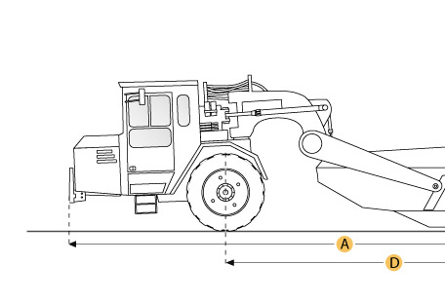

Selected Dimensions
Dimensions
A. Overall Length | 46.9 ft in | 14280 mm
B. Overall Width | 12.9 ft in | 3940 mm
C. Overall Height | 14.1 ft in | 4290 mm
D. Wheelbase | 28.8 ft in | 8770 mm

Specification
Tractor Engine
Make | Caterpillar
Model | 3408
Gross Power | 450 hp | 335.6 kw
Displacement | 1098.4 cu in | 18 L
Scraper Engine
Make | Caterpillar
Model | 3306
Gross Power | 250 hp | 186.4 kw
Displacement | 640.7 cu in | 10.5 L
Operational
Fuel Capacity | 322.3 gal | 1220 L
Tire Size | 37.25-35 30 PR (E-3)
Transmission
Number of Forward Gears | 7
Max Speed Forward | 29.8 mph | 48 km/h
Weights
Total Operating - empty | 112089.6 lb | 50843 kg
Front Axel - empty | 66132.1 lb | 29997 kg
Rear Axel - empty | 45957.6 lb | 20846 kg
Total Operating - Loaded | 187090.9 lb | 84863 kg
Front Axel - loaded | 91674.8 lb | 41583 kg
Rear Axel - loaded | 95416.1 lb | 43280 kg
Bowl
Rated Payload | 75001.3 lb | 34020 kg
Heaped Capactiy | 31 yd3 | 23.7 m3
Struck Capacity | 21.1 yd3 | 16.1 m3
Max Depth of Cut | 17.2 in | 437 mm
Width of Cut | 11.5 ft in | 3510 mm
Dimensions
Overall Length | 46.9 ft in | 14280 mm
Overall Width | 12.9 ft in | 3940 mm
Overall Height | 14.1 ft in | 4290 mm
Wheelbase | 28.8 ft in | 8770 mm
