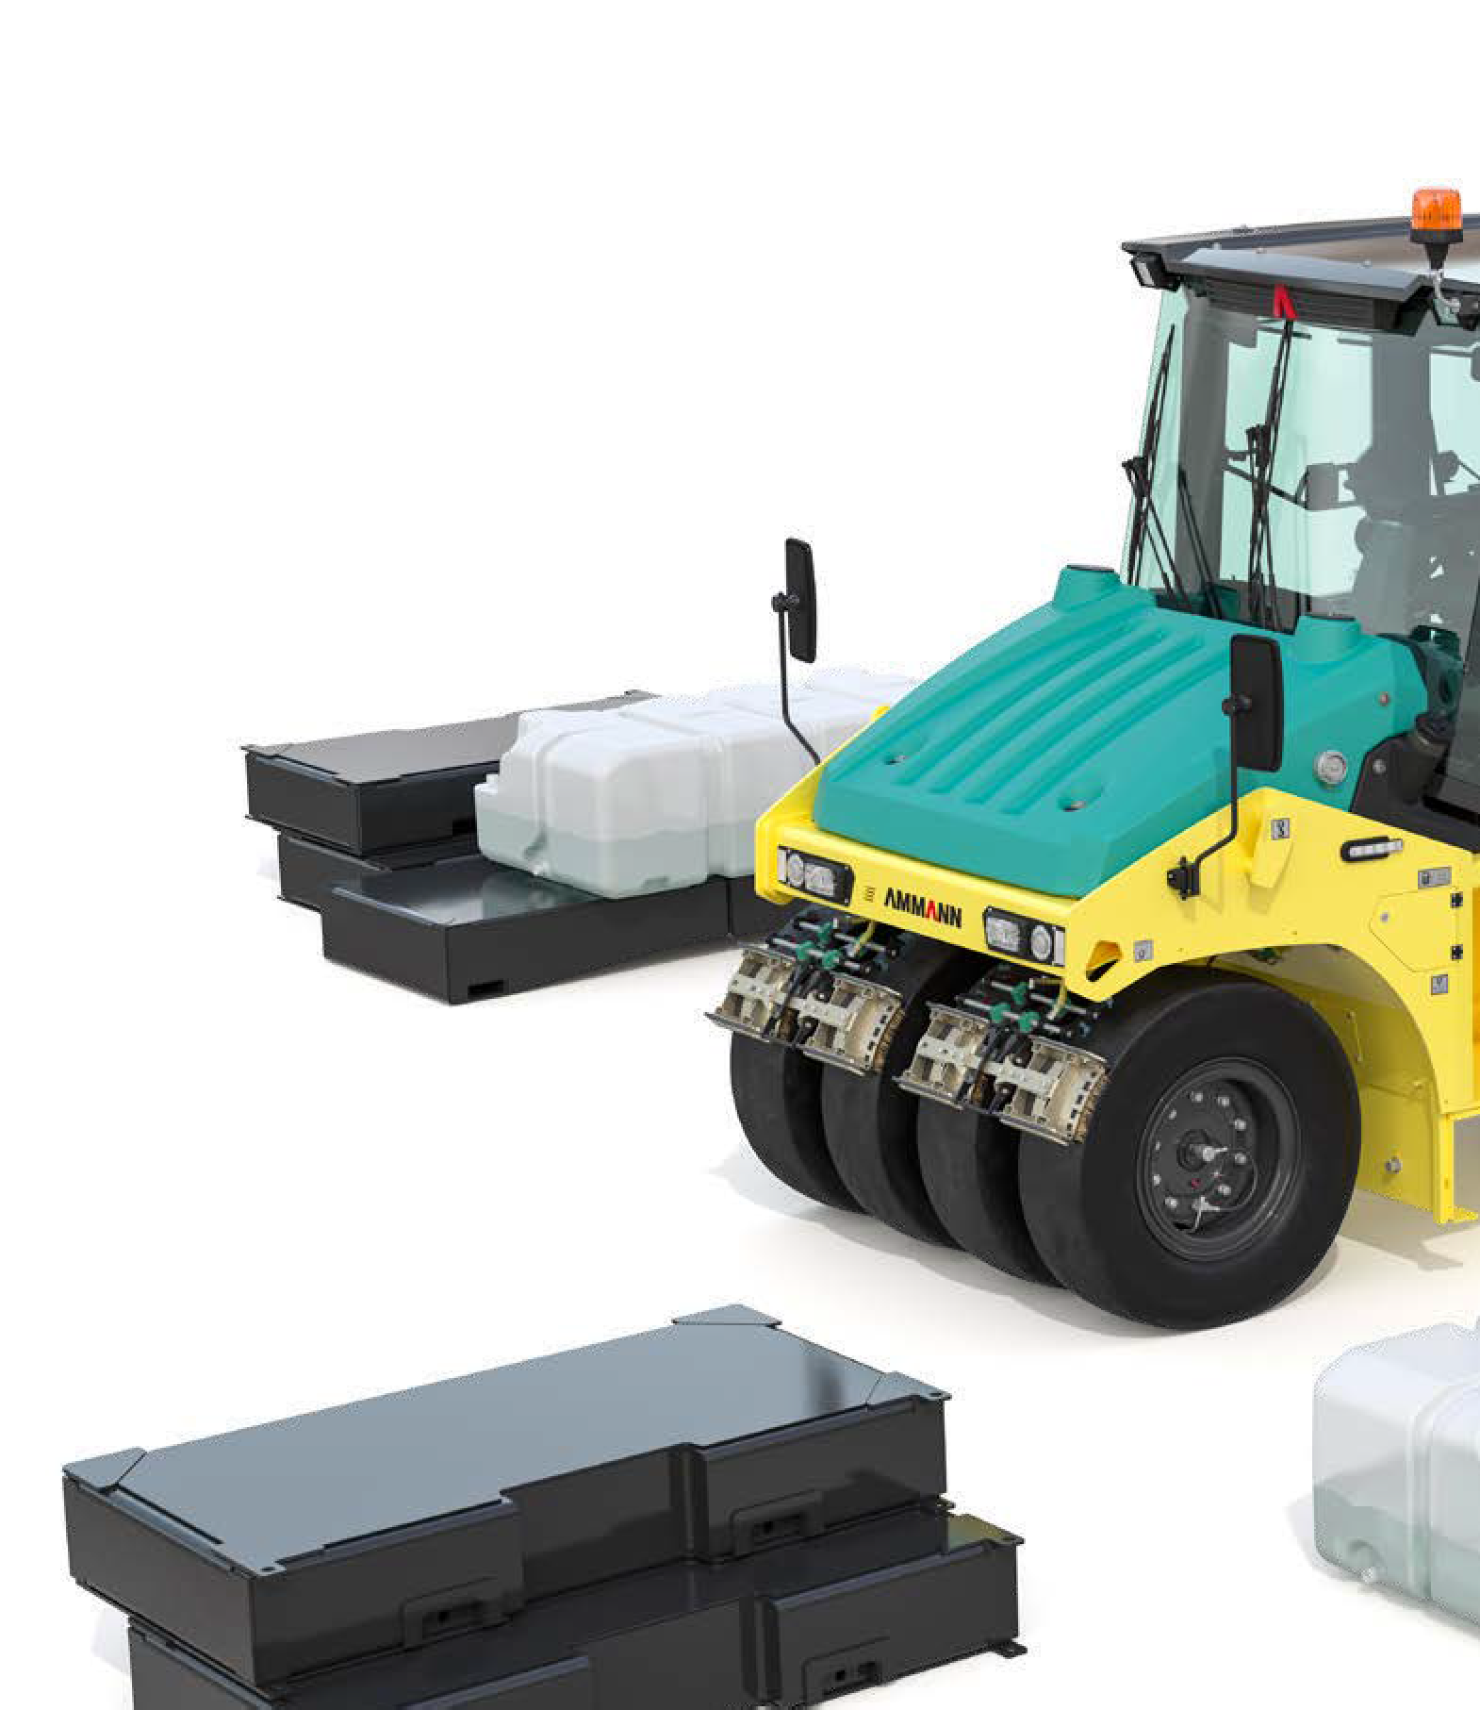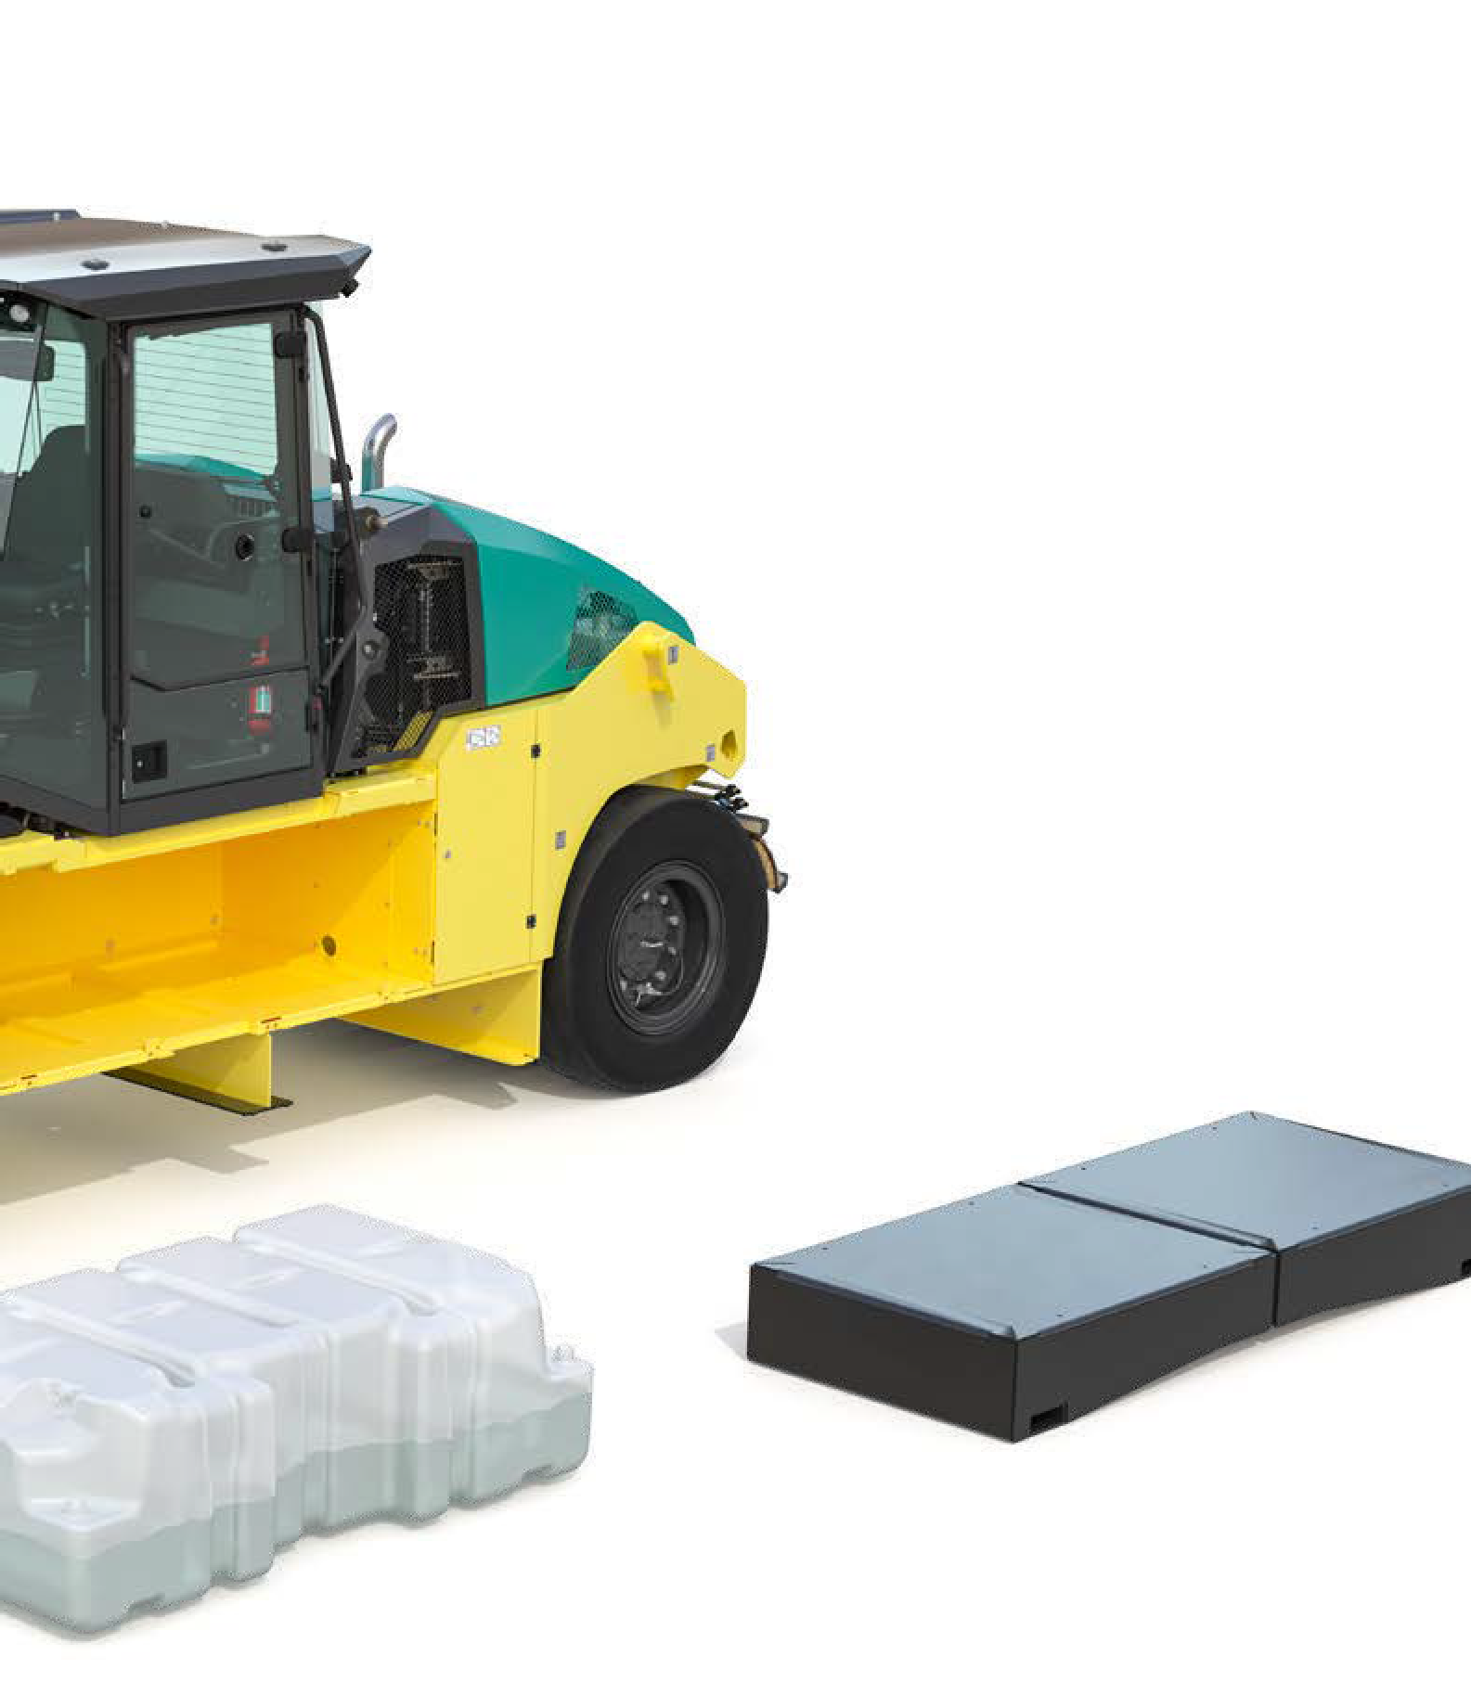

**INSIDE FRAME**

**Ballasting blocks: 0.7–10.4 tons**

* Empty ballast blocks inside frame

- 0,7 ton / 2 x 0,35t / 2x 0,5m3

* Empty ballast blocks inside frame

- 1,4 ton / 4 x 0,35t / 4x 0,5m3

* Ballast blocks inside frame

- 2,35 ton / 2 x 1,17t

* Ballast blocks inside frame

- 4,7 ton / 4 x 1,17t

* Ballast blocks inside frame

- 5.2 ton / 2x 2,6t

* Ballast blocks inside frame

- 10.4 ton / 4x 2,6t

**or Water ballast: up to 1.7m3**

* Water ballast tanks inside frame 1,8 ton / 2 x 0,9t

**UNDER FRAME**

**Ballasting blocks: 0.8–7 tons**

* Empty Ballast blocks under frame

- 0,8 ton / 4 x 0,2t / 4x 0,25m3

* Lower Ballast blocks under frame

- 3,2 ton / 4 x 0,8t

* Lower Ballast blocks under frame

- 7 ton / 4 x 1,75t

BALLASTING

SPACE UP TO 3m3

BALLASTING BLOCKS

0.8–7 tons

WATER BALLAST