CATERPILLAR 14m Motor Grader
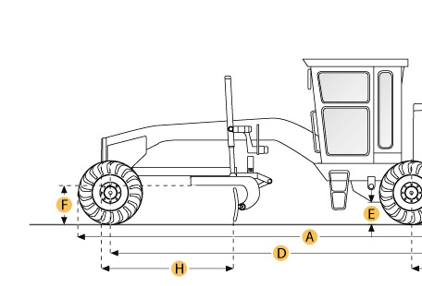

Selected Dimensions
Dimensions
A. Overall Length | 30.9 ft in | 9412 mm
B. Width Over Tires | 9.2 ft in | 2791 mm
C. Height to Top of Cab | 11.6 ft in | 3535 mm
D. Wheelbase | 21.5 ft in | 6559 mm
E. Rear Ground Clearance | 1.3 ft in | 383 mm
G. Tandem Axle Wheelbase | 5.4 ft in | 1656 mm
H. Blade Base | 9.3 ft in | 2842 mm

Specification
Engine
Make | Caterpillar
Model | C11 ACERT VHP
Net Power Gear 1-2 | 259 hp | 193 kw
Net Power Gear 3-4 | 274 hp | 204 kw
Power Measured @ | 1800 rpm
Net Power Gear 5-6 | 274 hp | 204 kw
Number of Cylinders | 6
Net Power Gears 7-8 | 274 hp | 204.3 kw
Max Power | 274 hp | 204.3 kw
Displacement | 677 cu in | 11.1 L
Operational
Std Operation Weight - Front Axle | 12611 lb | 5720 kg
Std Operation Weight - Rear Axle | 34522 lb | 15659 kg
Std Operation Weight - Total | 47133 lb | 21379 kg
Max Operation Weight - Front Axle | 21912 lb | 9939 kg
Max Operation Weight - Rear Axle | 44086 lb | 19997 kg
Max Operation Weight - Total | 65998 lb | 29936 kg
Fuel Capacity | 130 gal | 492 L
Cooling System Fluid Capacity | 12.3 gal | 46.5 L
Hydrauilc System Fluid Capacity | 15.9 gal | 60 L
Transmission Fluid Capacity | 23.5 gal | 89 L
Circle Gearbox Fluid Capacity | 1.6 gal | 6 L
Tandem Case Fluid Capacity (each) | 25.5 gal | 96.5 L
Transmission
Type | direct drive, power shift, countershaft
Number of Gears - Forward | 8
Number of Gears - Reverse | 6
Max Speed - Forward | 31 mph | 49.8 km/h
Max Speed - Reverse | 24.5 mph | 39.4 km/h
Steering
Articulation L/R | 20 degrees
Turning Radius | 25.9 ft in | 7.9 m
Front Axle
Wheel Lean | 17.1 degrees
Oscillation - Total | 32 degrees
Hydraulic System
Pump Type | variable displacement
Pump Flow | 74 gal/min | 280 L/min
Relief Valve Pressure | 3500 psi | 24150 kPa
Moldboard
Moldboard Width | 14 ft in | 4267 mm
Moldboard Height | 27 in | 688 mm
Moldboard Thickness | 1 in | 25 mm
Max Depth of Cut | 17.3 in | 438 mm
Side Shift Left | 29.1 in | 740 mm
Side Shift Right | 31.1 in | 790 mm
Blade Pull at Max Weight | 39678 lb | 17997 kg
Blade Down Pressure | 38666.9 lb | 17539 kg
Circle
Diameter | 71.8 in | 1822 mm
Shift Left | 25.5 in | 650 mm
Shift Right | 20.5 in | 520 mm
Max Reach Outside Tires - Left | 85.4 in | 2169 mm
Max Reach Outside Tires - Right | 89.7 in | 2279 mm
Max Lift Above Ground | 16.5 in | 419 mm
Blade Tip Angle - Front | 40 degrees
Blade Tip Angle - Rear | 5 degrees
Dimensions
Height to Top of Cab | 11.6 ft in | 3535 mm
Overall Length | 30.9 ft in | 9412 mm
Width Over Tires | 9.2 ft in | 2791 mm
Wheelbase | 21.5 ft in | 6559 mm
Blade Base | 9.3 ft in | 2842 mm
Tandem Axle Wheelbase | 5.4 ft in | 1656 mm
Rear Ground Clearance | 1.3 ft in | 383 mm

