Caterpillar PS500 Pneumatic Roller
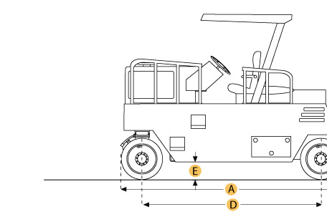

Selected Dimensions
Dimensions
A. Overall Length | 20.6 ft in | 6270 mm
B. Overall Width | 8.2 ft in | 2500 mm
C. Height to Top of ROPS | 11.9 ft in | 3630 mm
D. Wheelbase | 14.6 ft in | 4465 mm
E. Ground Clearance | 1.2 ft in | 360 mm

Specification
Engine
Make | Caterpillar
Model | 3208
Gross Power | 150 hp | 111.9 kw
Power Measured @ | 2300 rpm
Displacement | 636 cu in | 10.4 L
Number of Cylinders | 8
Operational
Fuel Capacity | 81.9 gal | 310 L
Engine Oil Capacity | 3.3 gal | 12.5 L
Water Spray Tank Fluid Capacity | 92.5 gal | 350 L
Max Speed | 16.5 mph | 26.6 km/h
Weights
Operating Weight - standard | 41887.8 lb | 19000 kg
Operating Weight - max ballast | 77161.8 lb | 35000 kg
Average Weight per Wheel - Max Ballast | 11023.1 lb | 5000 kg
Tires
Number of Tires - Front | 3
Number of Tires - Rear | 4
Standard Tire Size | 15.00R24
Dimensions
Overall Length | 20.6 ft in | 6270 mm
Overall Width | 8.2 ft in | 2500 mm
Height to Top of ROPS | 11.9 ft in | 3630 mm
Wheelbase | 14.6 ft in | 4465 mm
Ground Clearance | 1.2 ft in | 360 mm

