CATERPILLAR cs583c Vibratory Smooth Drum Roller
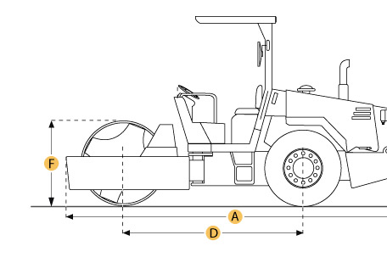

Selected Dimensions
Dimensions
A. Overall Length | 17.7 ft in | 5400 mm
B. Overall Width | 8.2 ft in | 2508 mm
C. Height to Top of Cab | 9.9 ft in | 3020 mm
D. Wheelbase | 9 ft in | 2740 mm
E. Ground Clearance | 19 in | 483 mm

Specification
Engine
Model | 3116T
Gross Power | 145 hp | 108.1 kw
Displacement | 402.8 cu in | 6.6 L
Operational
Operating Weight | 34083.5 lb | 15460 kg
Fuel Capacity | 58.1 gal | 220 L
Engine Oil Capacity | 5.3 gal | 20 L
Hydraulic System Fluid Capacity | 29.1 gal | 110 L
Max Speed | 8 mph | 12.8 km/h
Tires *if applicable | 23.1x26-8 ply
Drum
Drum Width | 83.9 in | 2130 mm
Drum Diameter | 59.8 in | 1520 mm
Vibration Frequency 1 | 30 Hz
Centrifugal Force - High | 31750 lb | 141.2 kN
Centrifugal Force - Low | 16675 lb | 74.2 kN
Dimensions
Overall Length | 17.7 ft in | 5400 mm
Overall Width | 8.2 ft in | 2508 mm
Height to Top of Cab | 9.9 ft in | 3020 mm
Wheelbase | 9 ft in | 2740 mm
Ground Clearance | 19 in | 483 mm

